arithmetic

# Design: lexer

As I covered in the Analysis, the point of the Lexer is to convert a plaintext input, which the computer cannot understand, into a list of tokens which hold meaning to the program, which can then be arranged into abstract syntax tree to be executed.

Because I am using an Object-Oriented approach, I have made a UML class diagram which shows the relationship of all the different classes.

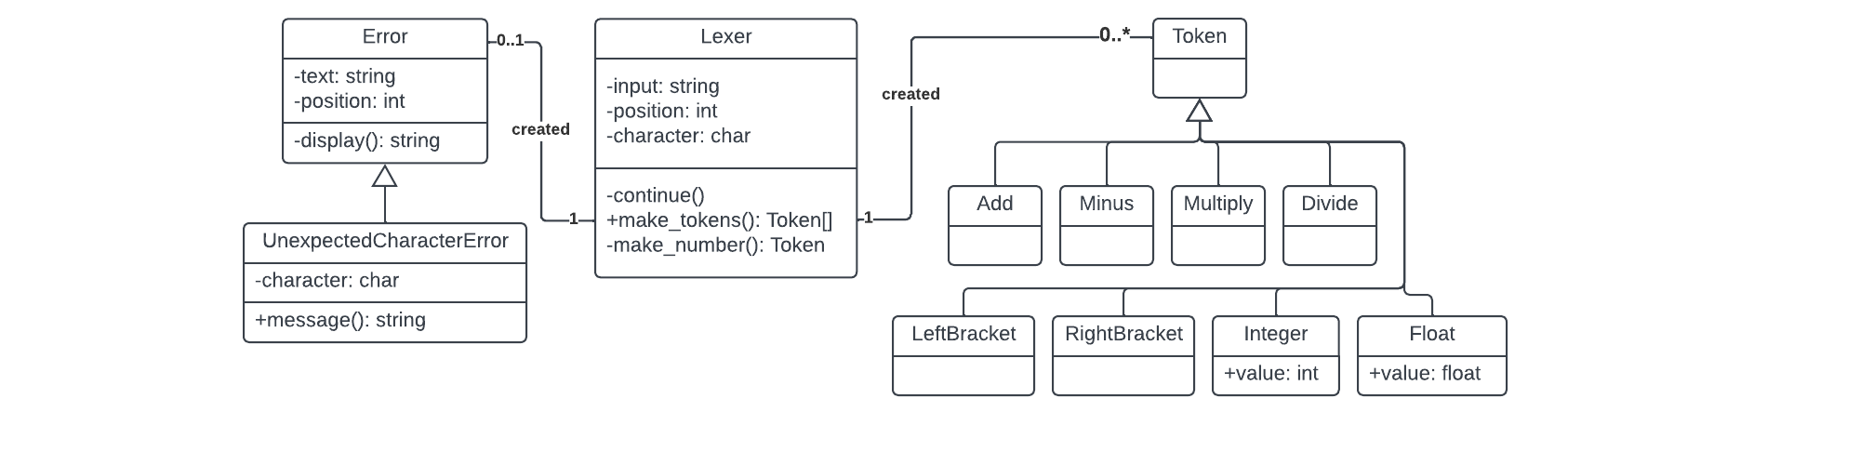I will then go ahead and explain each new section that has been added.

## Lexer

This is the main class in this section and will interact and link with all the others. It has an input property, for the plaintext, as well as a position and character property. Because the Lexer will function by iterating character by character through the plaintext input, these will keep track of the current position and character. All these properties will be assigned in the constructor.

🡺 continue()

This method will be called to advance through the input string, incrementing the position property and changing the character property to the corresponding value. However, if the end of the string has been reached, then the character will be set to null. This should help to avoid with any errors with accessing a character at an index beyond the length of the string, as this is the centralised method to update the character and ensure any progressions through the string are allowed.

🡺 make_tokens()

This is the method that will be called to generate tokens and will comprise of a while loop which repeatedly runs until the character property is null: until the entire input has been cycled through. For each iteration, the current character will undergo a series of checks, which will then, at the end, push the corresponding Token to an array of tokens. For example, if “+” is encountered, then an Add token will be pushed on that cycle. I will go through each of these checks in more detail later.

At the end of each cycle, the continue() method is called to proceed to the next character, or if the current character did not match any of the cases, then an instance of an UnexpectedCharacterError is returned because the program does not recognise it. Once all the characters are cycled through, the list of tokens will be returned, which will then be used by the Parser.

🡺 make_number()

This method will be called if the character in make_tokens() encounters a digit, because it may contain multiple different characters within the same Token. Generally, whenever a multiple-character Token needs to be made, make_tokens() will call this method whenever the first character has been detected, and will then push the result of the function to the stream of tokens.

make_number() will then continually call continue() and add the characters to an array until a non-digit is encountered. Full stops will also be added and will increment the value of a fullStops variable. When a non-digit is encountered, it stops the loop and the method will return an instance of an Integer or Float Token, depending on the number of full stops: with an Integer being made if none are present, and a Float with one. The value will be the characters in the array, typecasted into a number.

An additional check will have to be made if many full stops are present, so if fullStops exceeds one, an error will have to be returned, because a number cannot be defined with more than 1 full stop.

## Tokens

There will be a basic Token class, and then a unique child class for each type of token that exists. At this stage, these classes will be empty, because their code will be based on how they should be evaluated, which will come later in this section.

Therefore, a lot of these classes are empty, except Integer and Float, which will have a property called value, which will, obviously, store the value of that number. This will be set in their constructor methods.

Now, I will go through each of the different tokens, specifying how they will be created:

Add 🡺 “+” in make_tokens()  
Minus 🡺 “-” in make_tokens()  
Multiply 🡺 “*” in make_tokens()  
Divide 🡺 “/” in make_tokens()  
LeftBracket 🡺 “(” in make_tokens()  
RightBracket 🡺 “)” in make_tokens()  
Integer 🡺 A number with no full stops in make_number()  
Float 🡺 A number with one full stop in make_number()

For now, these are very basic, because the Lexer is only for arithmetic calculations, but in the future, when keywords, strings and other features will need to be added, the complexity will significantly increase.

## Errors

This will be the generic, parent class for all the different types of errors in the program. It will accept the position of the error in its constructor, as well as the plaintext of the input with the error, stored in a position and text properties respectively. It will have a single method.

🡺 display()

This is a method which will be used by all Error subclasses. It will use the text and position properties and return a two-line string of the line of text with an arrow “^” below. This will indicate exactly where the error occurred so that it will be easier for the user to precisely debug the issue.

### Unexpected Character Error

This subclass, alongside the position and text arguments, will also accept the character that called the error in its constructor. Therefore, whenever an error occurs, the Lexer’s character property can be passed into the function, and this will be used for displaying the error.

🡺 message()

This will return a string with an error message describing the issue for the user to understand, using the character that was passed to it to accurately describe the issue. This will include the result of the display() method at the end of this description, so that the visual position can also be shown.

In the future, all subclasses of Error will have a method called message(), so that whenever an error occurs, message() will be printed, and regardless of the error the issue will be outputted. This is an example of how polymorphism will be useful within the project, by having methods named the same between classes.

Overall, this should be the planning for the first Lexer stage complete. This first implementation should not be extremely complicated, but I need to focus on making the whole system very expandable, because everything else will build off this base lexer, so having the code be clean is very important.

### development notes

Throughout this whole project, I am going to be pasting a lot of different screenshots as proof, and testing, so I will be colour coding the borders of images for reference.

No border 🡺 This is code that I have written for the project.  
**Green border** 🡺 This is the code or output of a testcase that was successful.  
**Red border** 🡺 This is the code or output of a testcase that was a failure.

There may also be other, small fixes aligned over the code screenshots, which will be outlined in white. These are just small changes that originally caused errors, but I then fixed.

These borders will just break up the large number of screenshots and should make it easier to read through the write-up and recognise the purpose of each screenshot.

# Development: lexer

## the lexer

### base classes

I’ll start by creating the basic Lexer class, which includes the continue() function to increment the position and change the character property when called. I also made it so it is called once in the constructor, so that the Lexer will begin in the first position with the first character.

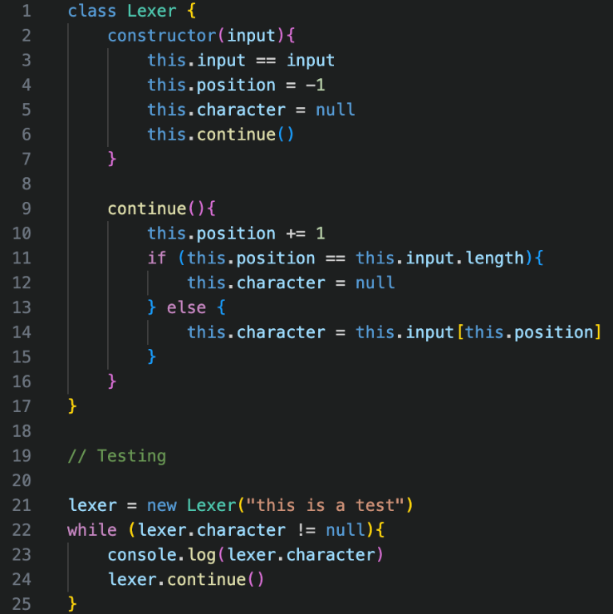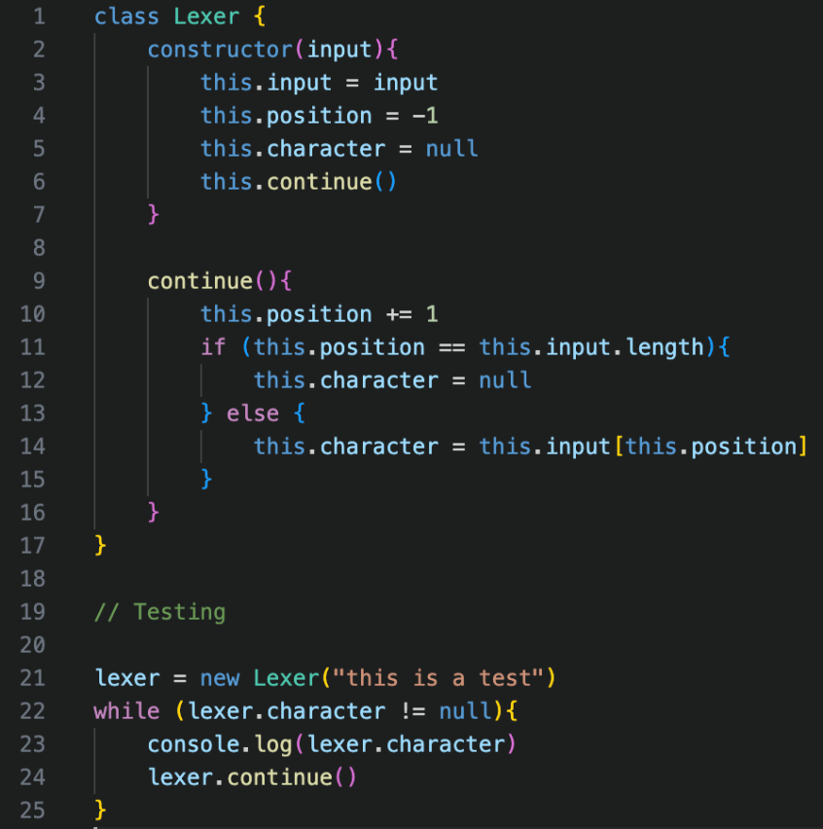

Initially, this had a small syntax error, which you can see that I corrected. I then wrote a quick test case to check that continue() functioned correctly, and the loop correctly outputted all the characters, showing that the continue() method works as expected.

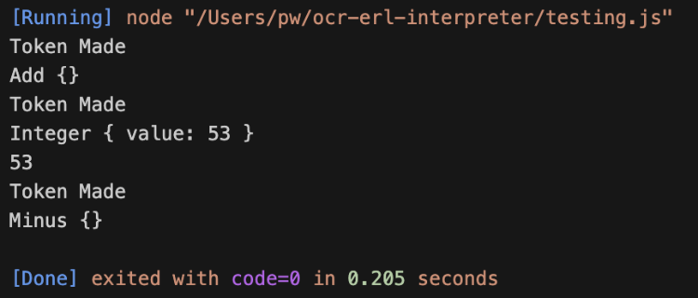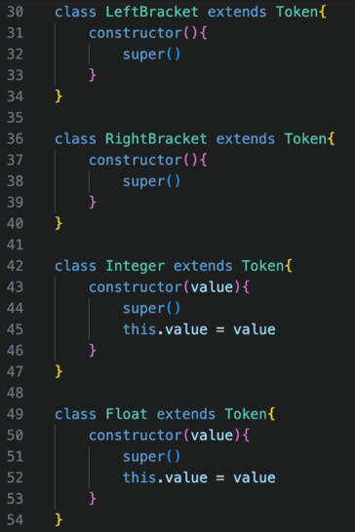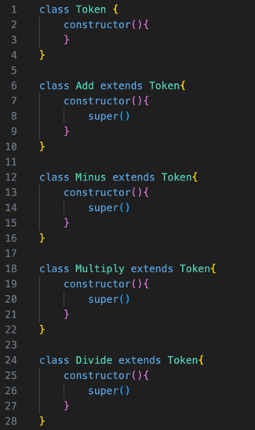Then, I added each of the Token classes, which are now just all very empty but will be filled up later. I also gave them each a constructor method, which for now just called the super() constructor, but in the future should have additional code.

The small test case just to ensure that the tokens were properly created, with the values of the Integer also being stored correctly, so now I am ready to generate some tokens.

### A screen shot of a computer screen Description automatically generatedBasic token generation

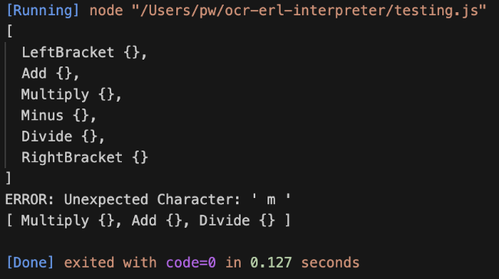I have implemented each of the cases by comparing the characters to their corresponding tokens. I will implement proper error handling later, but for now, I will just output a message.

As shown, the test cases for these two worked, with the whitespace being ignored and only the actual characters being registered.

### A black background with text and numbers Description automatically generatedNumber tokens

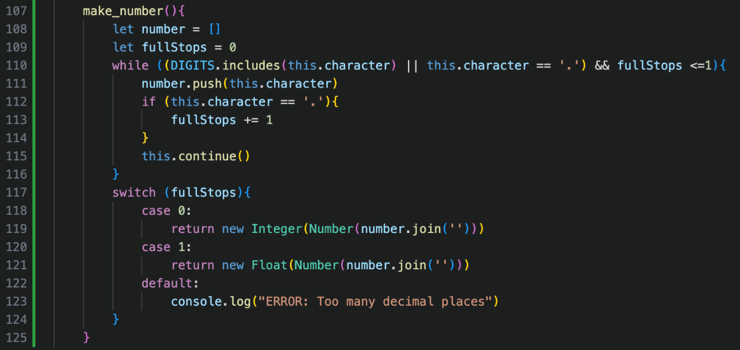DIGITS is declared globally as a constant so it can be re-used.

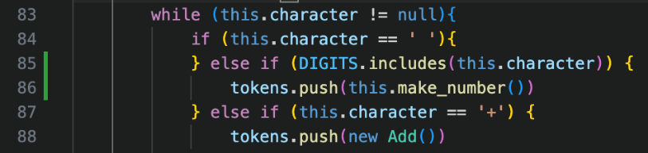The make_number() method is added much like in the design description.

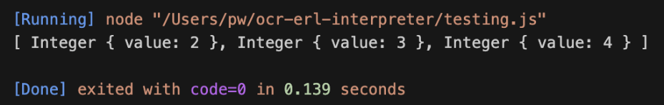The check in make_tokens() is also added, which will call the method when a DIGIT is encountered,

However, my test case failed which led to me doing a series of small tests to debug the error.

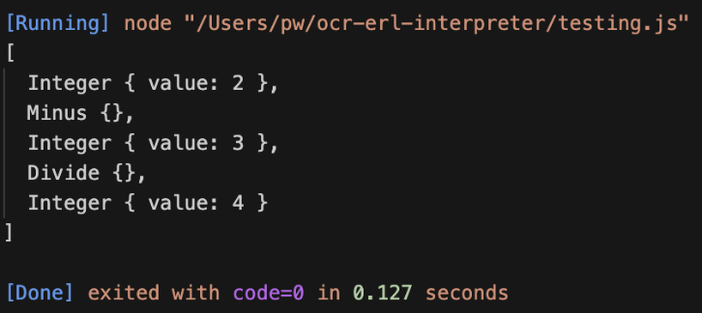The second case showed that the character after a number would be skipped, which therefore made me think that it was an issue with continue(), rather than an issue with the code itself.

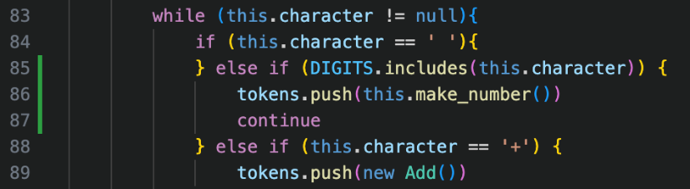When looking through the code, I realised that the continue() method was called twice after a number was completed, once in the last iteration within the make_number() loop, to check that the next character is not a digit, but then it is also called at the end of a cycle in the make_tokens() loop, which therefore ignores the character directly after the number, which is incorrect.

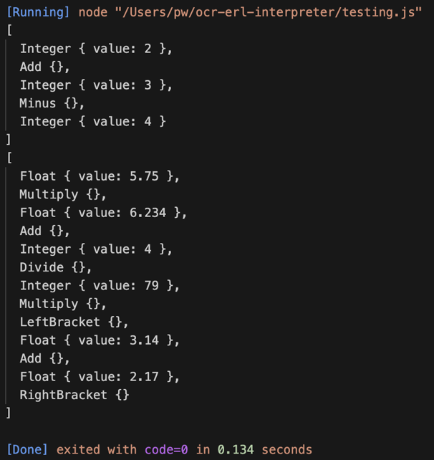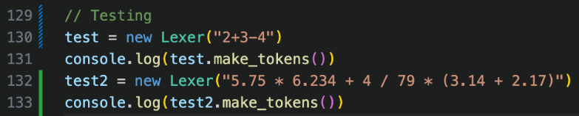The solution to this is by adding a continue keyword in make_tokens() at the end of the number creation case. This skips to the next cycle of the while loop without running the rest of the cod, which therefore ignores the second continue() at the end, so will not skip a character.

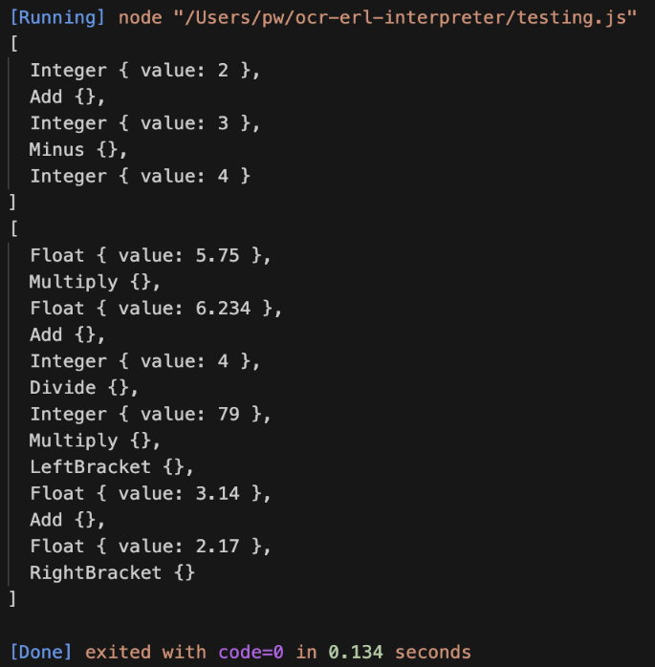Now that this has been fixed, the tokens are generated as expected, as shown by my test cases.  
  
Now, this is all the lexing required for this stage of development, so now the proper error handling needs to be added before continuing to parsing, but overall, this implementation has been relatively easy.

## A screen shot of a computer code Description automatically generatedError handlIng

I started by creating the Error class, and then the display() method.

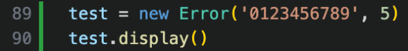The test case I will be using for this is on the right, and I am expecting for the arrow to be pointing at the number 5.

This was my initial attempt at creating the method, which involved repeatedly adding a space to a list based on the position of the list.

However, the test case for this was completely wrong.

There were two issues with this first attempt.

Firstly, the outputted message used commas instead of spaces, which would insert a space between each argument, so replacing these with spaces would concatenate them properly.

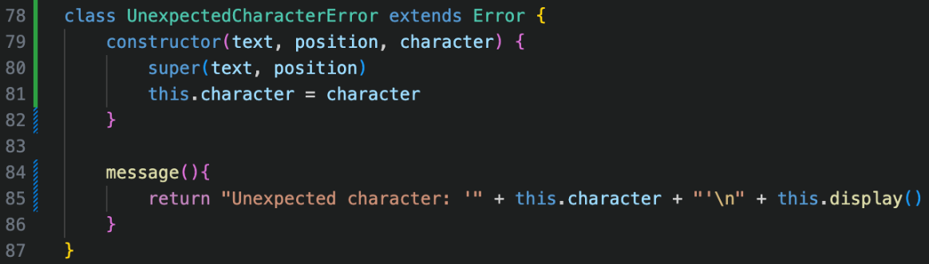Then, the loop needed to be changed to use a < rather than a <= sign, as it still iterated one time too many, but after this change it correctly pointed at the right character.

From there, creating the Unexpected Character Error class was very simple, with message() being as described in the plan.

My final two test cases proved that this system is correctly working.

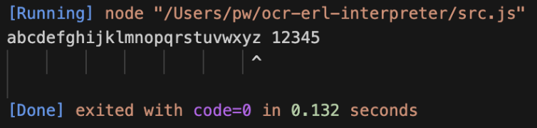

### Errors implementation

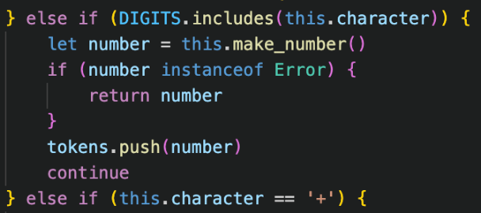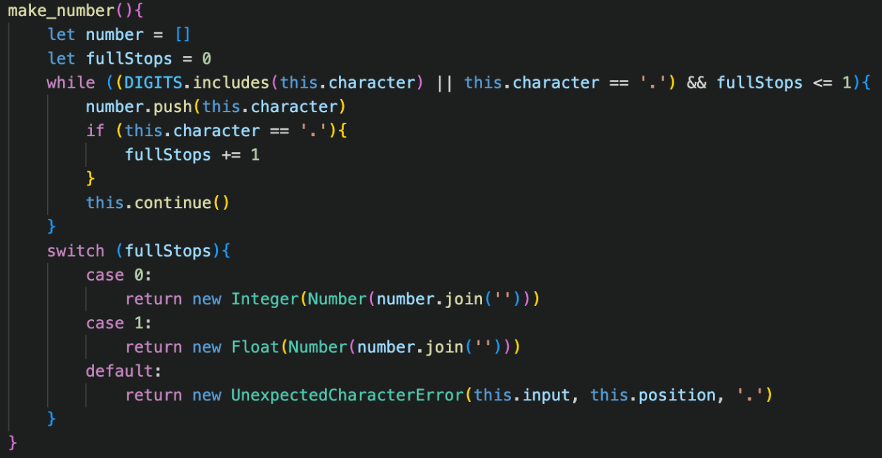Firstly, all the temporary Error print statements can be directly replaced by returning a new instance of the Error in make_tokens() and make_number()

However, when an error is returned in make_number(), it would currently just add the error to the tokens array, so we need to check if what is returned from make_number() is an error, and if it is we return that error in the make_tokens() function, which would stop processing, and otherwise we would just add the result to the end of the list as per usual.

For the medium-term, I have created a new Run class, which will not be kept in the long-term solution. However, for now, it will be useful to link the different stages of lexing, parsing and code execution and will speed up the testing, as the whole sequence will not have to be rewritten, and can all be tested with one line.

Now I need to test each of the different error cases to ensure the message is outputted.

You can see how useful the new Run class will be by the very short test case on the left, which also shows how unexpected character errors correctly work.

However, having too many full stops in make_number() return the error with the wrong position, which is due to an issue in make_number() with how continue() is called before returning the error message.

I therefore redesigned the make_number() method to check for the full stop errors before calling continue(). I could have just returned the position -1, however I feel this approach makes a lot more logical sense if I have to read it again in the future.

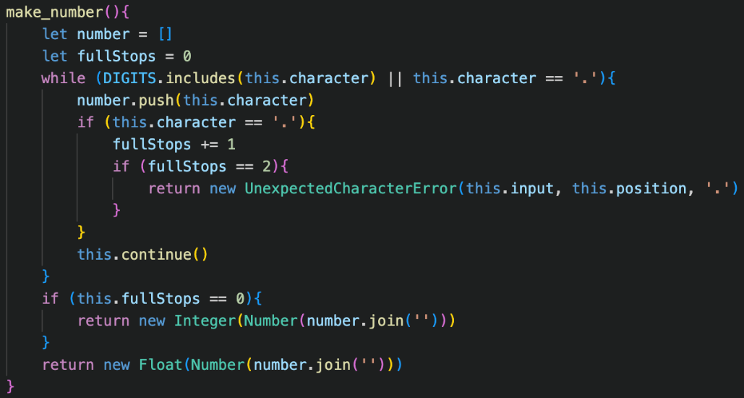

It works properly now, pointing to the full stop.

I also checked that Run works with normal cases, and it still outputs the correct tokens, which it does so now all the features have been added.

## Cleaning Up

Although I have now added all the features that I want for this stage of development, I think it is important to come back and refine previous code, adding commenting and making improvements so that I don’t get as confused when I return later in the development process.

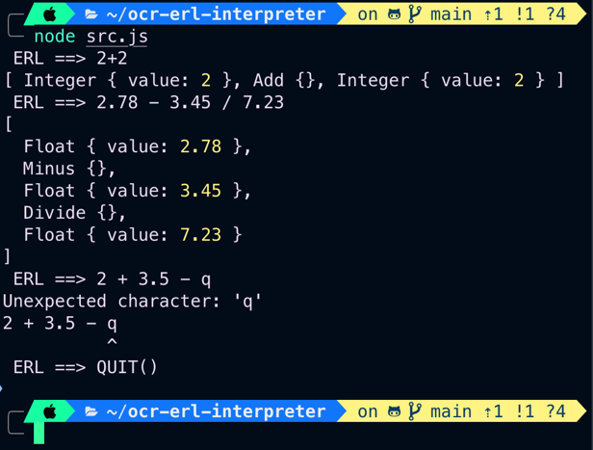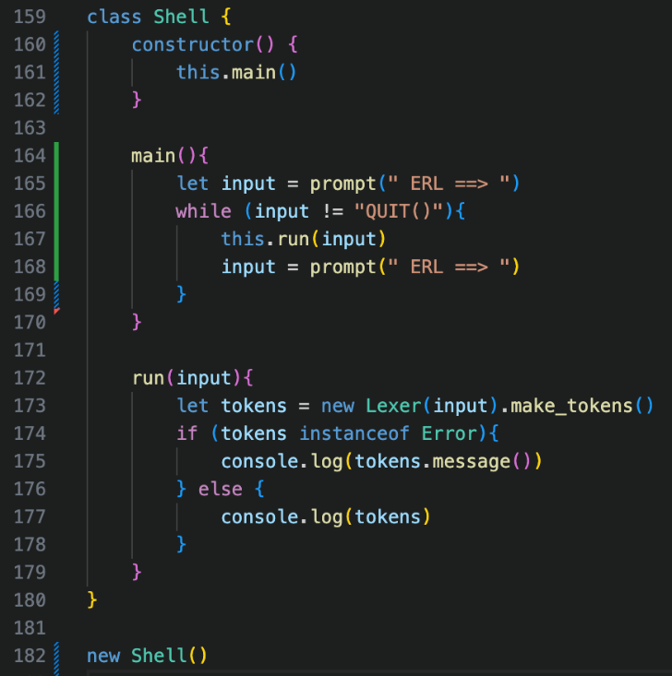I firstly changed the old Run class into a new Shell class, again, a temporary solution which will make test cases easier, but will take in a user input directly from the user and will then output the result.

I decided to use the prompt-sync module for this, which I installed via node, which just allows me to take in inputs from a terminal, because Node JS does not have an easy way to do this.

I also made it so the shell would stop executing when QUIT() was entered, another arbitrary decision but this is just a medium-term testing implementation.

### better javascript

I’m new to JavaScript, so I tried to research some easier ways to implement features I’d already written. One example is using template literals, which make it easier to format strings.

An example of where I used this is in UnexpectedCharacterError’s display()

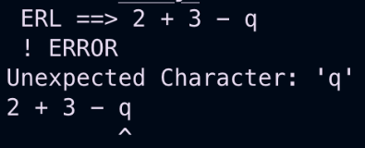These are equivalent to f-strings in python, which I am familiar with, and make it easier to integrate variables into a string. I also redesigned the error message format slightly.

Additionally, I found that a repeat() method existed, which I could then use in display() instead of my clunky loop solution, which simplifies the code significantly, and still results in the same result.

The next useful feature is the conditional ternary operator, which can be used within JavaScript with an expression ? statement : statement syntax. It is the equivalent of checking if the expression is true, and then returns the first statement if it is true, or the second if it is false, and removes redundant if statements.

For example, I used it within the continue() method, to check if the position is equal to the length, which then sets the current character to null if true, or the corresponding character if false.  
I also changed this in some other places, and it just removes some additional if statements in places. All of these are just minor changes, but I’m hoping to get into a good habit of using them for the rest of the program, because using as many built-in JavaScript functions as possible is great.

Overall, this section was simple but important, and now I can continue onto the parser, which is where the whole process becomes a lot more complicated.

# Design: parser

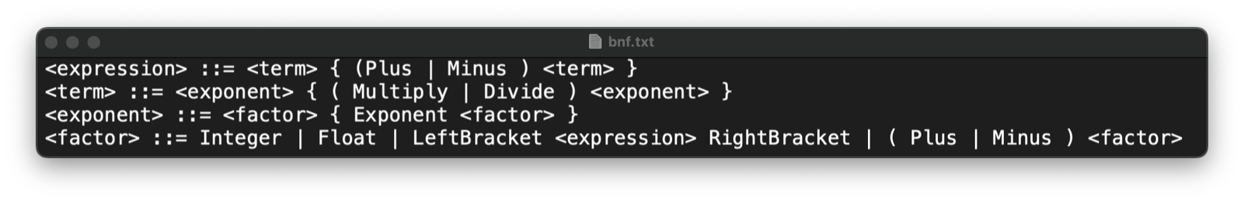

Above is the BNF for this section of implementing the parser. This example looks more complex than the version I used in analysis, but the overall idea is the same. Before I go into the exact details of how I will implement the classes and methods to allow parsing to work, I will explain the process in slightly more depth because my analysis description was very brief.

This will include some basic pseudocode, which is my overall current idea of how I would like the parsing to function, based off my reading from the analysis stage. Note that this pseudocode will be heavily abstracted for the purpose of the explanation, and is not exactly how I will implement it

## The complexities of parsing

In our previous example, we thought of parsing being constructed from the bottom up: from <term> to <factor> to <expr>. This process occurs the other way around, using recursion, from the top down, with <expr>s constructing the <factor>s, which make the <term>s.

In our code, we will have a different method for parsing the <expr>, the <term>, and the <factor>, each of which will call upon the next. Because this will be done in a class within a single object, the current tokens and positions do not have to be passed between these methods, and instead will be stored as properties, and I will be using the same continue() format as I did in the lexer to progress through these different tokens. This is where having an Object-Oriented approach makes the code significantly simpler.

This means that, after one method has completed parsing, you can call it again and the current position and character are maintained. Our parser will work by each of our different methods repeatedly calling the method that is “below” it, whilst checking that the current character is one of the corresponding characters.

Take the expression method for example, <expr> is defined as <term>s separated by pluses or minuses.

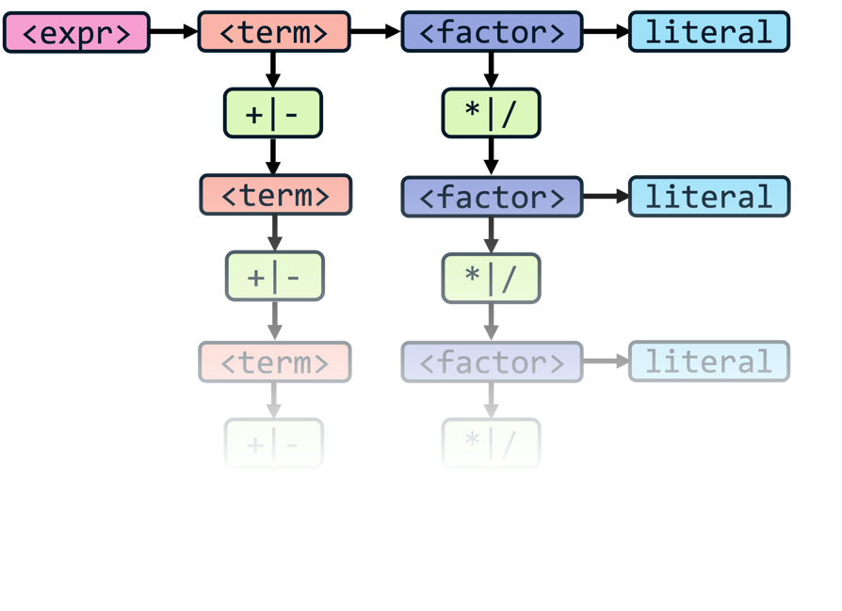Therefore, the expression method will call the term method when it is called, to parse the term, and then check that the next token is a plus or a minus. If it is, the process will repeat, calling the term method until there are no more pluses or minuses left.

Likewise, the term method will call the factor method, and then check if the next token is a * or a /. If it is, then the term method is called again, and this also repeats.

I think this diagram is useful to visualise this repeated pattern, because that is the best way to thinking about it: a long chain.

It is also now important to visualise the code itself. Diagrams are important to visualise the overall structure but explaining it in pseudocode helps to bridge between the logic into the code itself, and I think in this case, pseudocode makes it a lot easier to understand, but in a very abstract form.

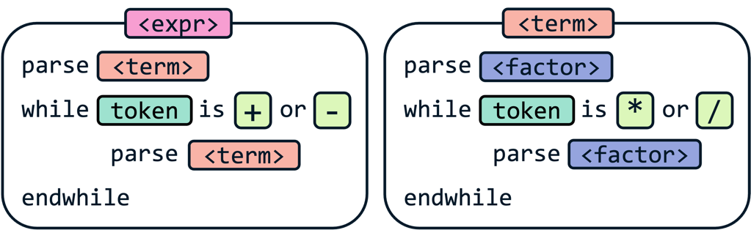On the left is this idea written in code, repeatedly calling and parsing the next method whilst checking that the token following the previous parsing is one of the permitted tokens. By themselves, these individual methods are very simple, and comprise mainly of this single loop.

The complex part of this is realising what this means on a larger scale. I feel it is best to think of this as “filling in the gaps”, and so that each time, for instance, the expression method calls the term method, the next token will either be a plus, minus or the end of the input (so long as there are no syntax errors).

This is because the term method will deal with all the multiplication, division, and literals by itself, so all that is left to the expression method is the multiple steps of addition and subtraction. So again, whenever the term method is called, the expression method anticipates and knows that there will be a plus, minus or the end of the string, and it is this expectation that the parser will be in the right position which is difficult to grasp.

This is a great example of decomposition: each individual method by itself is extremely simple, just iterating over the first few steps, but it’s the chaining of these methods that creates a lot of abstraction and solves a very complicated problem in the meantime.

This also ensures the two main principles of parsing are followed. The precedence is maintained by having the first method to be called the most generic and lowest-precedence one, in this case the expression method, because it will immediately call the factor() method, which will arrange any multiplication and division, until there are no more left, at which point it will return to then do any addition and subtraction, which means it has less priority and is of lower precedence.

The associativity is also maintained, because the while loop within each method will iterate through the tokens, therefore the left-most tokens will be reached before the rightmost ones, however this will make more sense when we begin to construct some abstract syntax trees.

## Construction

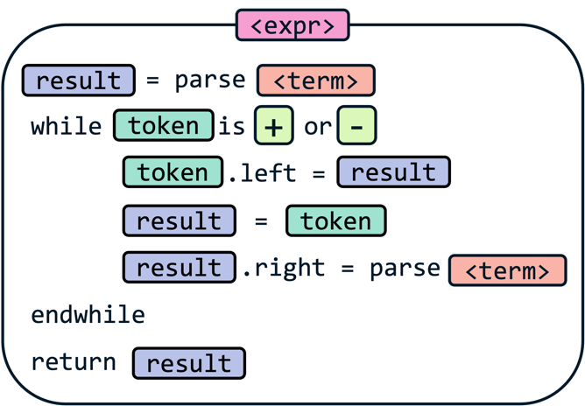Now that we know in which order build our tree, we must construct it. All the operator tokens will have a left property and a right property, representing the two things they are operating on, which will form the foundation of our tree, and allow for chains of these operators to be made.

Here, the result variable stores the current contents of the abstract syntax tree. Whenever a new operator is encountered in the loop, it will become the new root of the tree. Therefore, the old tree will become it’s left child, because it occurred before it, and when the next method is parsed, its result will be stored in the right property, because it is what follows it. Finally, this tree is then stored in result for the next iteration.

The expression method example is shown on the left, and result will be returned at the end, which will return the abstract syntax tree at the end of that section of parsing.

This is the same with all the methods, and again they can be “expected” to be correct. Therefore, when the term method is called, a correctly arranged multiplication and division tree will be returned.

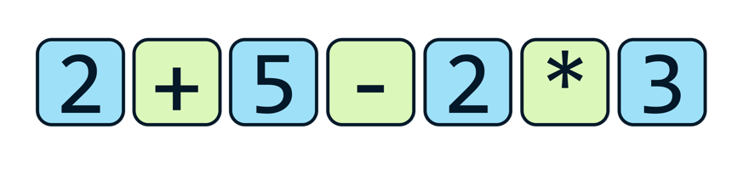An example should hopefully help illustrate this, so say the expression method is called on this input:  
🡺 The term method is called and returns an Integer with value 2  
🡺 The current token is a Plus, so its left property is set to the result: an Integer with value 2  
🡺 The term method is called again and returns an integer with value 5  
🡺 This is set as the right property of the Plus token, which now has two children

🡺 The new current token is a Minus, so its left property is set to the previous result  
 🡺 This means its left property is now a Plus token which has two Integer children

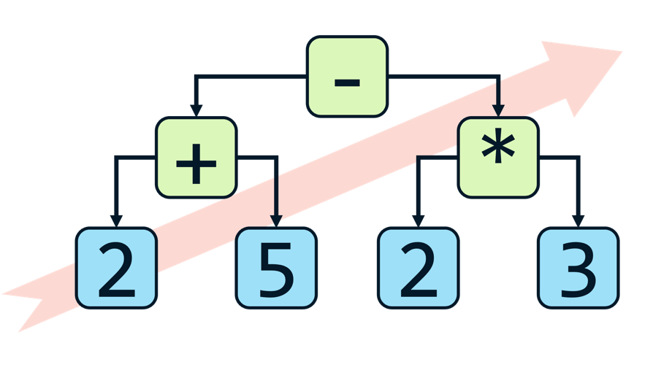🡺 The term method is called again, and now returns a Multiply Token  
 🡺 This Multiply Token has a left child of Integer 2 and a right child of Integer 3  
🡺 This Multiply Token is set as the right child of the Minus token  
🡺 There is now no new current token so the expression method is complete and returns the Minus.

As you can see, this results in this abstract syntax tree being formed, which is built from the bottom-left to the top-right. Because the lower parts of the tree will be evaluated first, this shows how precedence and associativity are maintained: with the multiplication and first plus being executed before the second minus.

It is good to try and visualise each one of the steps as this tree expanding, growing upwards and to the right, as the tree will always grow one node taller on each iteration of a method, because the new token that is encountered will become the tree for that specific tree.

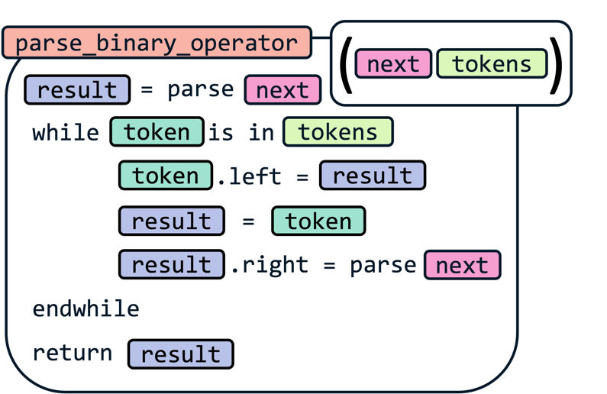Finally, it is worth thinking about how this solution can be generalised, because these methods follow the same generic format, but just with different tokens that are allowed, and different methods that need to be called next.

The example method on the left takes in two inputs for these unknowns, and now can be called by each of the different methods, vastly reducing code repetition in the interpreter, because the same steps are followed every time. Note that the factor method will have a completely different process, which I will explain soon.

Overall, I hope this explanation has helped, because it took my head a while to wrap around these concepts. In terms of implementation, it should not be that complex, because the methods themselves are very simple, but realising how they work, and why they work is much more important, and has been very interesting for me to discover.

These concepts will also carry into the rest of the interpreter, and essentially the entire parser is different ways of calling other methods with a higher precedence, so this arithmetic example is important to get.

## Integrating parsing

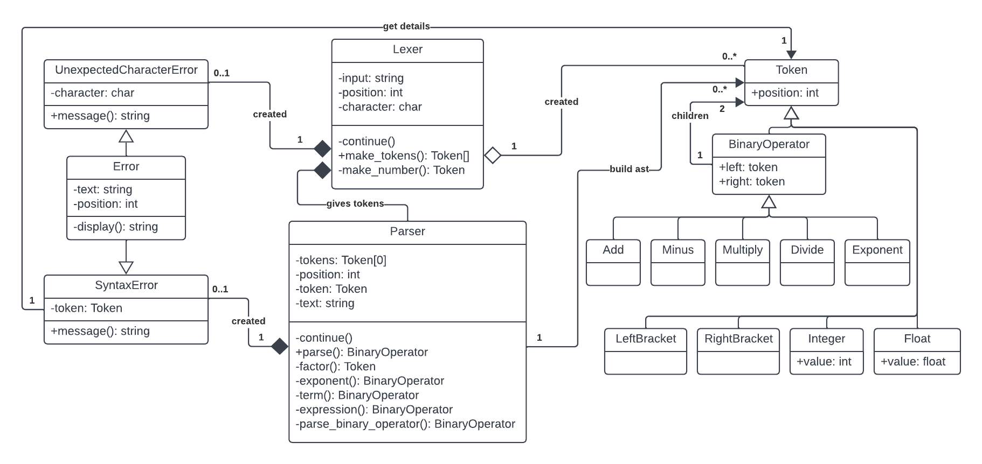Now let’s get back to our implementation and have a look into how our properties will allow us to parse according to our BNF rules, with the expanded UML diagram.



### Token updates

No huge updates in terms of new code, but mainly additions of small features:

🡺 Position attribute given to all Token classes.

This allows for error handling to function, as the position for each token must be remembered so that the display() methods will still function and point to the token that has the error.

🡺 Binary Operator class is a parent class of all arithmetic classes.  
🡺 All Binary Operator classes given properties for left and right child nodes.

This allows us to construct abstract syntax trees using the Tokens, but it is the new Parser class which changes these left and right properties to the correct values, and they will be null by default.

🡺 New Exponent class is created.

I forgot to include this in the original Lexer, but it’s addition should be very straightforward: adding an extra line to make_tokens(), but I will properly show this at the time.

### Errors

The addition of a new Syntax Error class for the Parser to use. This will take in the parameters of the text and the token which caused the error to occur. In the super() call in the constructor, it will pass the position property of the token that it was given, as this will be the position of the token that cause the error.

Therefore, display() will correctly work, and the message() function will be customised for the error messages that occur based on this token.

## Parser

In its constructor method, it will take in the stream of tokens from the lexer, which will be stored in the tokens property, as well as the original text, stored as text, to be passed to any syntax errors that occur so the correct message will be displayed.

It will also include a position and token property, which are direct equivalents of the position and character properties in the Lexer, allowing us to cycle through the tokens and keep it consistent.

🡺 continue()

Again, replicated from the Lexer, incrementing the position on each call, and setting the token property to the corresponding token in the tokens list. This will also set the token to null if the length is exceeded.

🡺 parse()

This is the main method to be called, which will return the abstract syntax tree when called. More specifically, it will return the root node, which will have the children that contain the rest of the tree. Additionally, a Syntax Error may also be returned if the stream of tokens was invalid.

In the future, this method will also recognise which “type” of line the code is. For instance, whether it is an assignment, an if statement, or just an expression. It would then call the corresponding method for whatever is required. However, for now, it will call the expression method, as we are only parsing arithmetic expressions, so this is the correct method to call, and will return its result.

Finally, after the expression() method has been called, if the current token is not null it means that the entire stream of tokens has not been parsed, meaning that there was an error in the syntax. In this case, it would mean that there were two literals in a row in the expression, as otherwise the expression would be able to be continually parsed, so therefore a Syntax Error is returned, with the current token being passed into it, as it is this double literal that would have caused the issue to occur.

### the parsing functions

🡺 parse_binary_operator()

This is our generic property which I discussed in the explanation. Therefore, it takes in the next function to be called and an array of the valid tokens to check through.

It also must be able to deal with any errors it receives from methods it calls, so that syntax errors do not get built into the abstract syntax tree. Therefore, whenever it calls a method, it will check if the result is an instance of an Error, and if it is then it will be returned. This will therefore pass the error up the chain of different methods, so it reaches parse() and will be returned there.

🡺 expression()

Calls parse_binary_operator() method with the next method being the term() method, and the array of valid tokens being Add and Minus and returns the result.

🡺 term()

Calls parse_binary_operator() method with the next method being the exponent() method, and the array of valid tokens being Multiply and Divide and returns the result.

🡺 exponent()

Calls parse_binary_operator() method with the next method being the factor() method, and the array of valid tokens being only Exponent and returns the result.

🡺 factor()

This stage is more complex than the others, as shown by the BNF definition, and it does not just call parse_binary_operator() because it has a few different cases.

Firstly, we check if the current token Is either an Integer or a Float, and if it is, then we will continue() past it, and return that prior token, because a factor can be either of these.

Secondly, if the current token is a LeftBracket, then we continue() past it and call the expression() method. This will then return the corresponding AST that was between the brackets, and then the following token is checked so that it is a right bracket. If it is, then the expression() result can be returned, and it will be built into the abstract syntax tree. Therefore, the bracket tokens will not end up inside the abstract syntax tree, which is good because they have no actual meaning or operations, and are only used to specify precedence, which they do in arranging the AST.

It the next token is not a RightBracket, then the brackets were not properly closed, and a SyntaxError can be created and returned.

Later on, I will need to also include unary operators into the factor() segment, so that negative numbers can also be created, however I will add this after these features have been added, to not have too much to add in one section.

\

# development: parser

This initial code is copied from the lexer, and the basic test case worked.

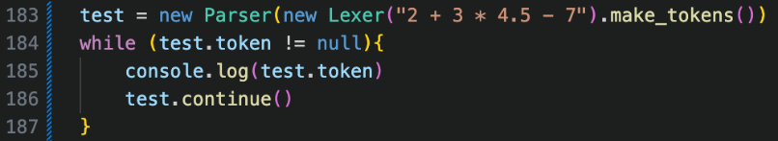

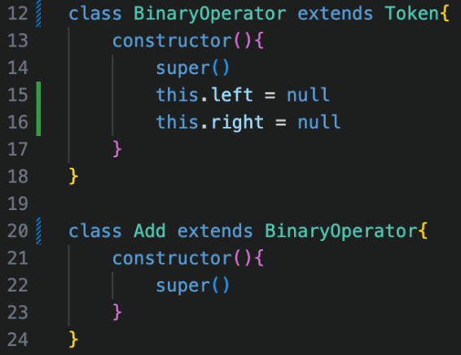

I added the Binary Operator class which extends Token, and then changed Add, Minus, Multiply and Divide to extend it as well. This just reduces code repeating.

Then I began implementing the expression() method, which will use the following test case. The end goal is to have an Add token, with the left child being an Add token with 2 Integer children of 2 and 3, and the right child being an Integer of 4.

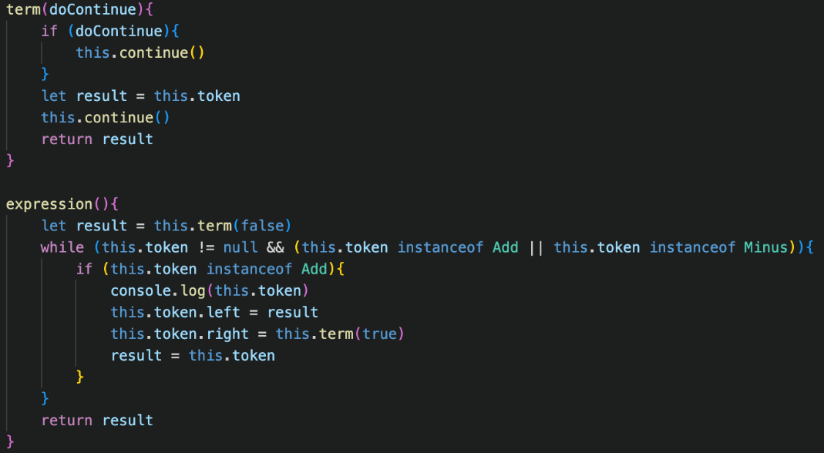

I am going to build the different sections one at a time to ensure that they are working, so this first version is moreso a proof of concept, and figuring out if the basics work, before adding the proper methods later on.

The term() method is completely temporary, and there is no generic method yet, but I made this very basic version to test if my basic expression method would work.

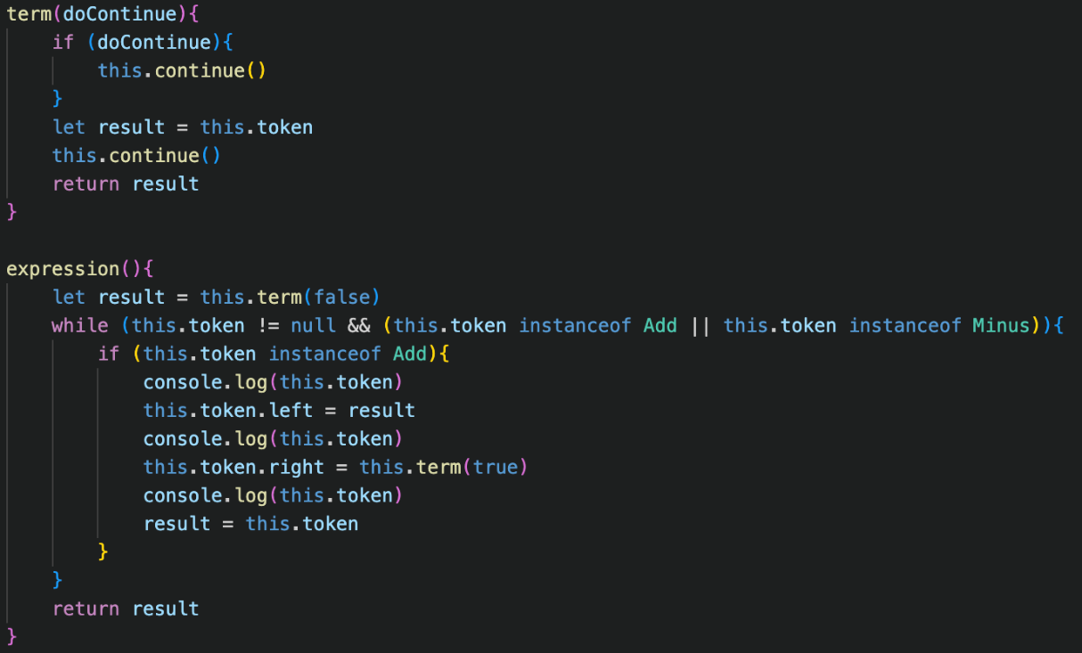And when running the test case, nothing was outputted, which showed how the basic test failed.

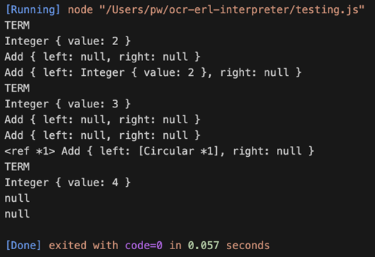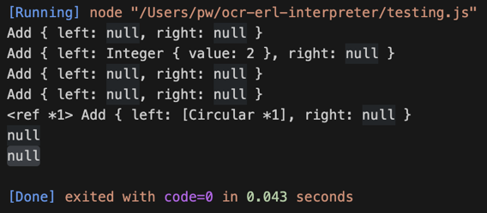When adding some output statements to track the tokens, it showed that one of the Add tokens was being set as its own left child, showing that the construction was somehow broken, which I thought was something wrong with how I was using continue() in my method.

With some extra output statements, it shows that the first stage of construction is working correctly, and that the Integer is correctly set to the left child, but after this the code broke, and this weird circular issue was occurring. However, the terms are correct, so continue() must be used correctly.

### the solution

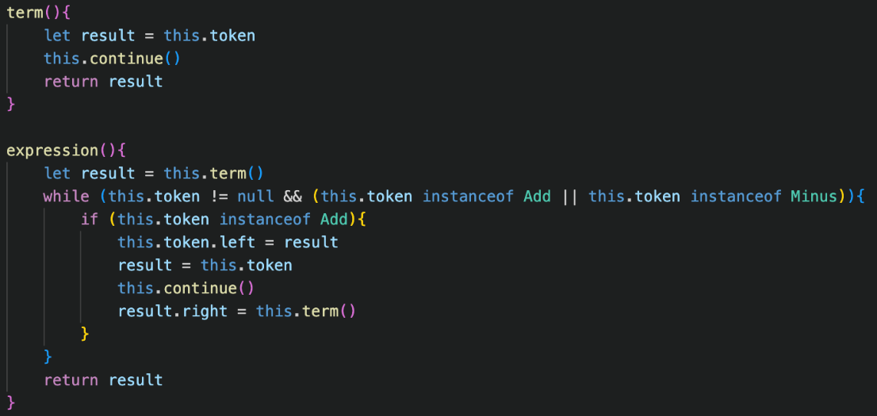However, the issue was with my original expression code, because I did not consider that the token property would change after the term() method is called, which is obvious with hindsight, because it had been continued() past, however I did not consider this in the moment, and instead was using the incorrect token, so the old syntax tree was completely discarded and a new, broken one was created.

After I understood that this would change, I rearranged my code slightly so that result would be set to the token before term() was called for a second time, and then I would set the right property of result to the result, which would still hold the old operation node, so it should correctly build the tree.

The new changes to the code can be seen on the left.

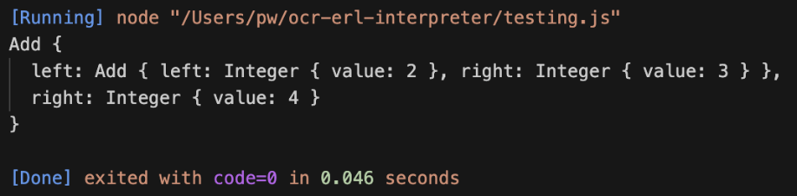 Now that I was more familiar with how continue() and the token property worked, I changed term to no longer have the redundant parameter, and to instead call continue() before it, making the code much more readable and consistent.

As shown above, the test functions now, building the correct syntax tree, so this section is complete.

## OTHER OPERATIONS

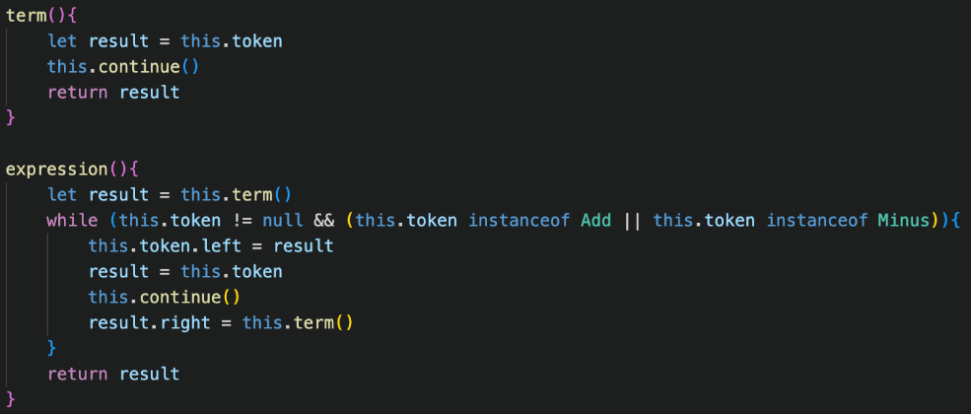Now I needed to add the three other arithmetic operations, starting with Minus.

This was a lot easier than I thought, and the code ended up being simpler than before, as I removed the redundant check for if the token was an Add, because Add and Minus would have been built in the same way due to their identical precedence.

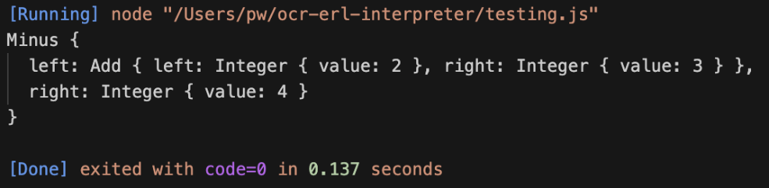As shown on the left, this immediately allowed for subtraction to be built into the abstract syntax tree, so this operator is completely implemented.

### multiplication and division

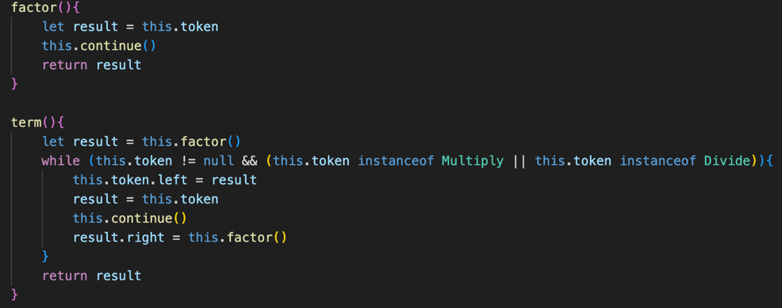Before adding the generic method, I duplicated the code from expression into term, changing the valid tokens to Multiply and Divide, and made it call factor() instead, which is the old term() method.

I then ran the following test case:

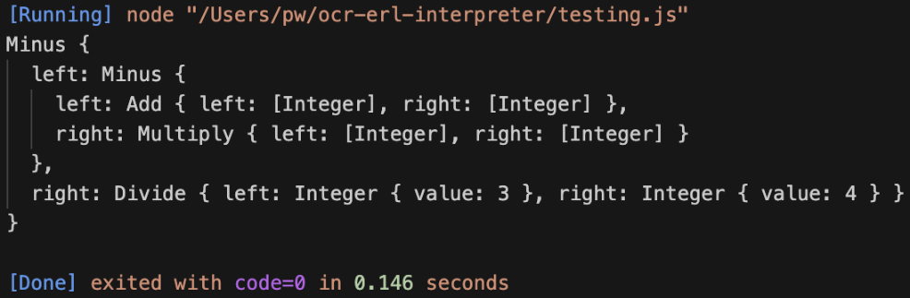As shown on the left, this produced the correct tree: with multiplication and division having priority from left to right, and then addition and subtraction. This is great, and is really promising to show that the system will work, but now I need to reduce the large amount of code repetition.

### generalising.

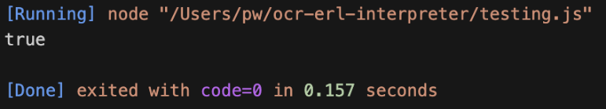This was not in the plan, but I created a new check_instance() method, which will accept an array of different classes, and it will check if the current token is an instance of any of them and will return true or false accordingly. This can therefore be used within our generic method, for example, for expressions, it will be passed an array for Plus and Minus, to check if the next iteration must occur.

The test case for this proved that it works as expected.

Now, I copied the old expression code into the new parse_binary_operator() method, changing it so that it the nextFunction argument would be called instead of term() being called, and so that it uses check_instance() on the tokens argument.

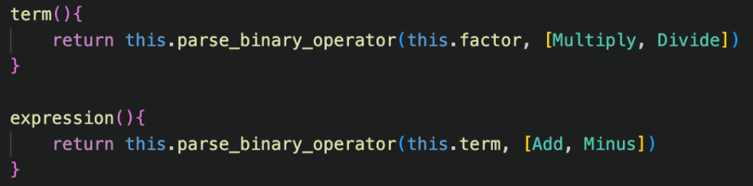This naming may be slightly poor, as methods are passed to nextFunction, however the overall functionality is the same.

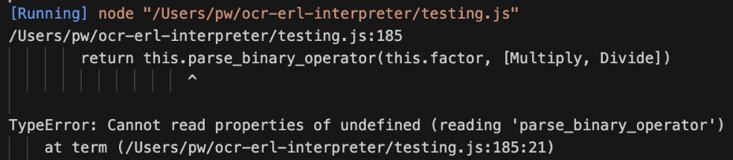How this is used is shown on the left, with the first argument being the next function to be called, follow by the array of usable functions.

check_instance() is very useful in this case, as it allows for any number of tokens to be in the tokens array, compared to the hold system which just had a fixed number of or statements, this is more dynamic.

However, instantly an error occurred, with the message saying that parse_binary_operator() was undefined. At first, this confused me, but after some debugging using lots of output statements, but after I researched into the problem, I realised that this was an issue with JavaScript rather than my code.

“this” represents the instance of a class in JavaScript, so it can be used to access all the attributes and methods of the specific object. However, “this” is not specific to only classes, but as JavaScript is an object-oriented language, what “this” references changes based on the context.

In my case, the meaning of “this” was being changed so that it no longer referenced the instance of the Parser class but was referring to one of the methods that was calling it, because the long chain of methods calling each other had mutated the meaning of “this”.

This means that I can no longer rely on using “this”, because it is not consistent, and instead I need a different way of consistently accessing the current instance. My solution to this is to give every single method a parameter, called “self”, which will store the instance of the Parser. Therefore, this argument will be used exactly like “this”, however it is passed to the method rather than being a native keyword.

For this to function, every single method in the Parser will need to have this “self” parameter, so for consistency I am going to ensure that it is always the first parameter of every single method.

An example of how this is used is on the left, with parse_binary_operator(). The “self” parameter is first, and then the rest of the method uses “self” as if it were “this”, accessing the tokens using it, and calling continue() using it.

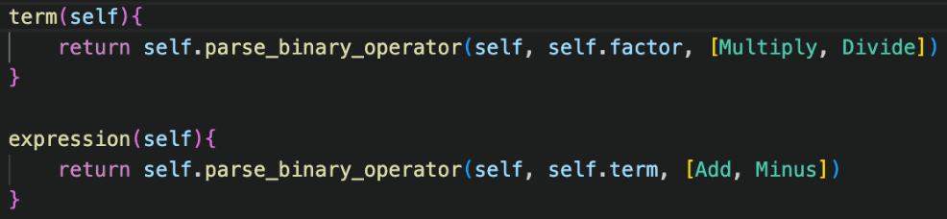Additionally, when calling nextFunction(), it passes self as an argument, so that the method can still access its own instance, and this chain of passing will continue throughout the program.

This new syntax will also have to be used in term() and expression() as shown on the left, essentially a direct replacement of “this” with “self” and passing it to any other methods it calls.

“self” originates from the parse() method, as this is the main method to be called from the interpreter, and this will pass “this” as an argument to expression(), starting the chain of “self”s with the original instance.

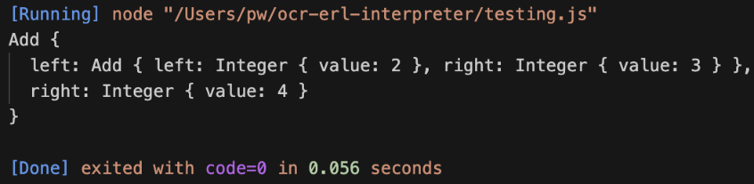As shown, this fixes the issue and now the generic method works. I do not love this implementation, as it feels kind of messy, and I’d much rather use this if it were possible, because now a lot of additional arguments are required in all the methods.

However, when researching the issue, it sounded like it was just a quirk of JavaScript, and there was no real workaround this issue, so it may be something I will have to deal with for the whole project.

### Exponents

The whole reason for constructing our code in this style is so it is a foundation for the future and can be easily expanded to include new features into the interpreters, such as exponents.

To add them, firstly the new class must be defined and extend the Binary Operator class, and the make_tokens() method must be altered to create a new Exponent when “^” is encountered.

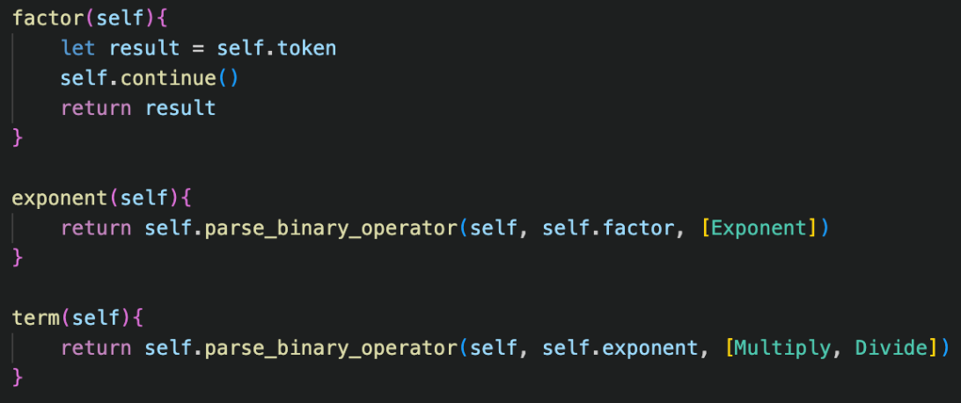From here, as exponents have a higher precedence than multiplication and divison in bodmas, the exponent() is added, with the nextFunction being factor(), and the valid token being Exponent in an array, so that it works with check_instance().

term() must now be changed to call exponent() instead of factor(), to properly weave it into the system.

Already, this implementation immedaitely works, without any issues. This really shows how easy it is to expand with this system, and is very positive for the rest of development, because new features can be added so easily.

## Brackets

Now that the other lines of BNF have been implemented, it leaves us with the factor() method to work on.

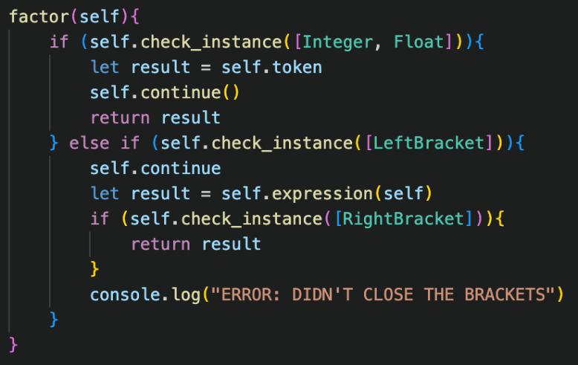My first attempt of implementation matched the description in the design phase. The new Left Bracket check had a temporary outputted error message if the token after expression() was called was not a Right Bracket, to be changed later.

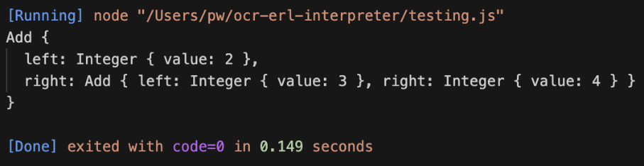The test case above initially failed, and after outputting the tokens, I realised it was stuck on the LeftBracket, and then that the () were missing after the continue() call, which was causing the issue,

After this was fixed, the abstract syntax tree was in the correct order, and the brackets were working as intended. To ensure it worked perfectly, I had to try a few other test cases.

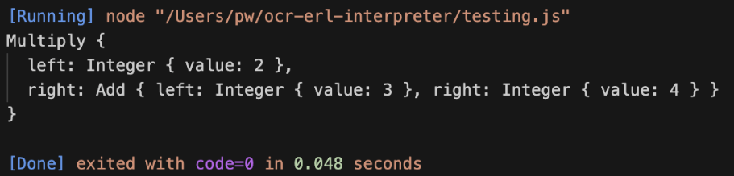The test case for having the brackets in the middle of the input failed, and somehow all of the tokens after the closing bracket were not being built into the abstract syntax tree.

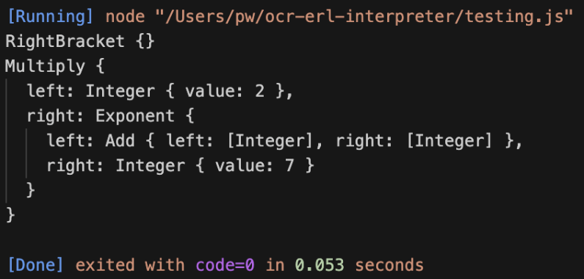Again, after some more debugging, it was because continue() was not being called to progress past the RightBracket.

This meant that the tokens after it were never reached, which explained why the tokens were being discarded. After adding the continue() call, the correct AST was then produced.

### other test cases

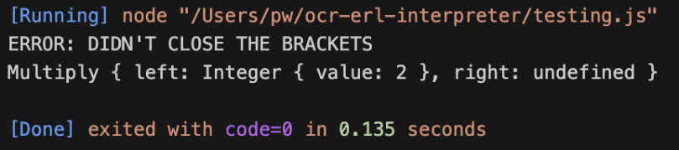The test cases for unclosed brackets worked as expected, with the temporary error message being outputted. Later I will ensure that this returns a proper error, however for now this is sufficient to show that the check for invalid bracket usage is correct.

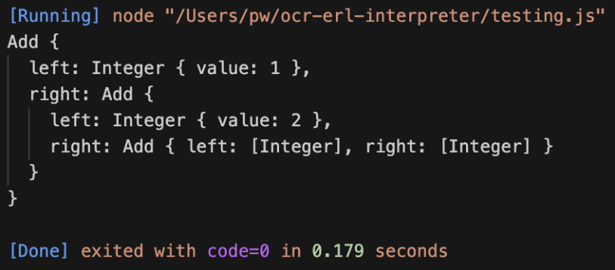Finally, I need to test for multiple layers of nested brackets.

As shown, the correct AST was produced, and the correct order of operations has been made.

This therefore concludes this section on brackets. Again, reasonably simple, but I did have issues on where I needed to continue(), and I am constantly having to debug different cases to make it function.

Now, I need to add proper error handling, and get rid of the temporary outputted error messages and account for a lot of the cases that completely break the program.

## Error handling

As you can see, currently if the input string has invalid syntax, the Parser attempts to produce an AST which is very incorrect, rather than reporting an error. Now, the program needs to be able to detect when there is an issue and report an error accordingly.

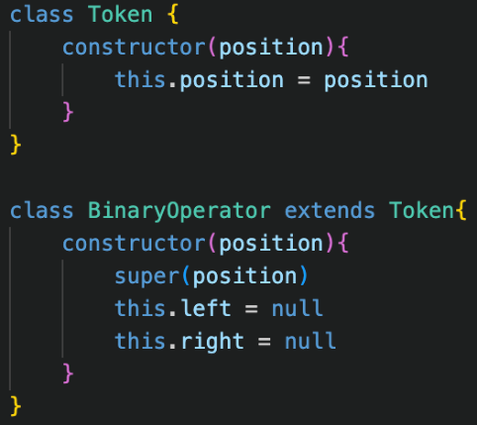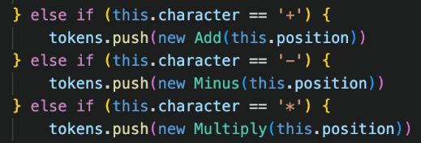The first stage is adding a position property to all token classes, which is needed for the display() property in the Error class to point to the error.

Because the position property needs to be given on creation of the token, this needs to be added to the Lexer. Therefore, in the make_tokens() method, the Lexer’s current position is passed into the constructor of the tokens, so therefore the position corresponds correctly with the plaintext, rather than other methods which may cause issues with whitespaces.

For tokens which take up more than one character, I’d like the position property to correspond to the position of the first character. So, for make_number(), we will have to assign the position to a variable at the start of the method, before using continue(), so that the original position is remembered, and then use that variable for the construction of the Integer or Float, as shown in the code below.

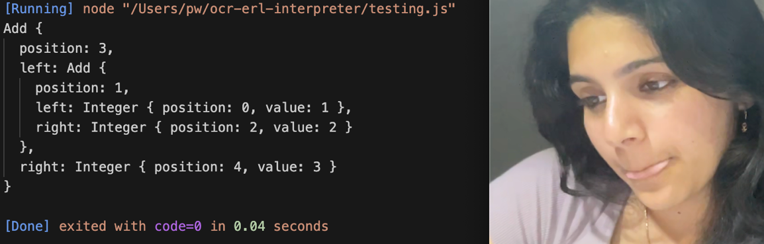When quickly testing this, the position attributes corresponded with their actual locations, so it was successful.

Now that this has been implemented, the Syntax Error class can finally be implemented.

### syntax errors

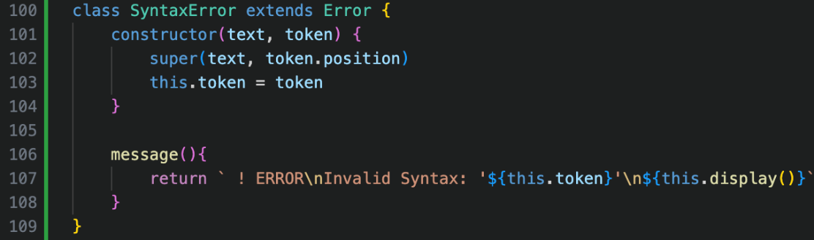The new class will accept the text and a token as its parameters and will pass the position of the token to the super() constructor, which allows the display() method to correctly work.

I also added the temporary error message, which will expand later.

To implement errors, the Parser’s constructor must take in the plaintext input.

Now, I can replace any outputted error messages with new Syntax Error returns, passing the text and the current token as the arguments. On the left, the first case is for unclosed brackets, and the second is for when no valid factor is detected: which is when two operators are used in a row, returning an error with the token that caused the issue.

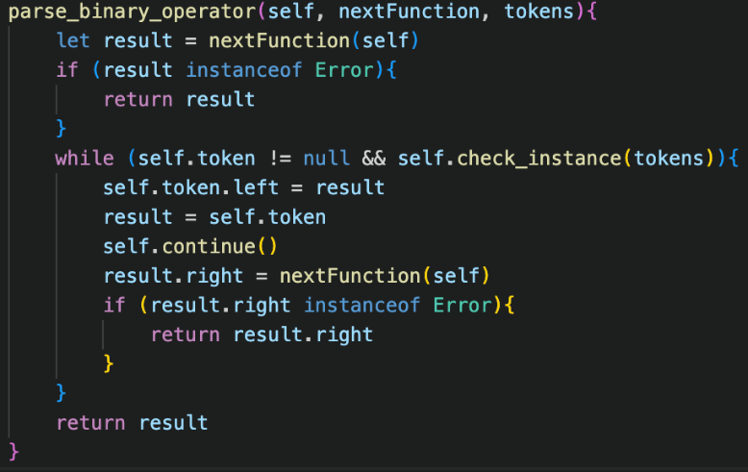parse_binary_operator() has now also been updated, so that it will check the result of any method it calls, to ensure that any errors do not get build into the abstract syntax tree, and that they will get returned and passed to the previous method.

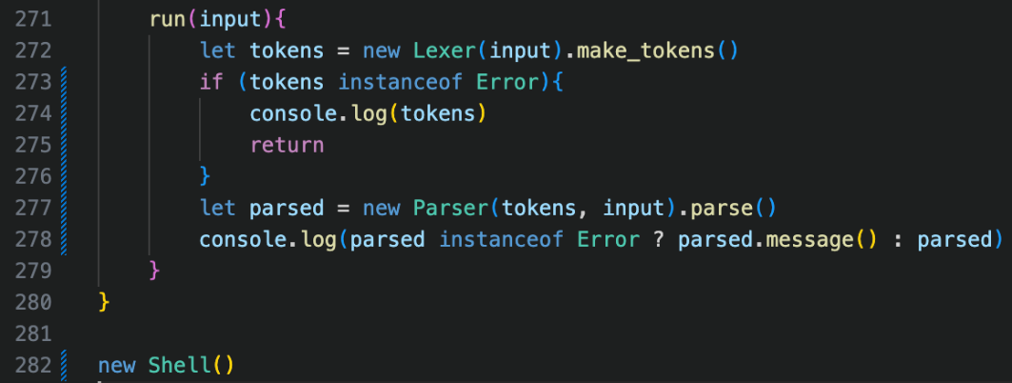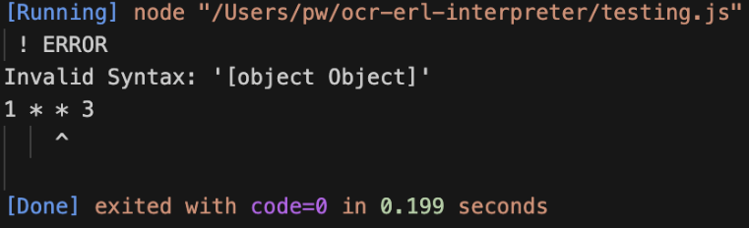Now, when running a test case as shown on the right, it is properly detected and returned, instead of a failed ast being produced. However, the error message is very broken, and provides no useful information.

Finally, I implemented the system back into our temporary Shell feature, so that our run() method would now correctly also parse the result from the lexer whilst checking for any errors, and if any are detected in the parser, they will be display()ed to show the error more clearly.

### A computer screen shot of a computer code Description automatically generatedcompleting error handling

One current issue is with unclosed brackets: because null is passed to the Syntax Error, so trying to access its position leads to JavaScript crashing.

To fix this, I store the original LeftBracket token in a variable before calling expression(), and if there is no RightBracket to close, then the error will be returned, but will pass this stored LeftBracket as the error token instead.

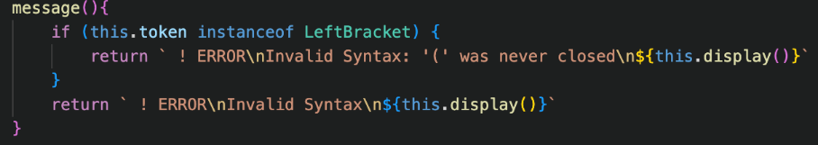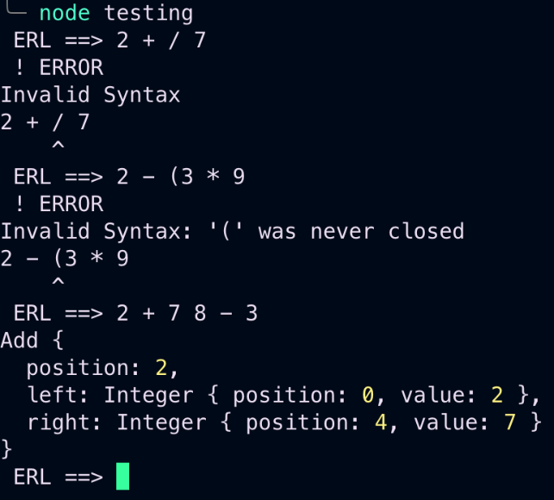I then also upgraded Syntax Error’s message() method, so that if the token is a LeftBracket, a custom error message will be returned.

This message is much more useful than “Invalid Syntax”.

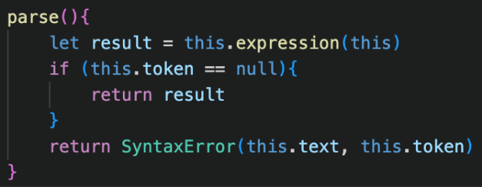The last error that needs to be implemented is for two literals in a row, where the code still attempts to produce a broken AST.

The solution to this is at the end of parse(), and if there are still remaining tokens left (so the current token is not null), it means the parser stopped before reaching the end, meaning that there must have been two numbers in a row, so a Syntax error can be returned.

Now, I just added two more error messages for the different cases, depending on the kind of token that was returned. As shown, now all of the different errors return a more descriptive message that matches the issue.

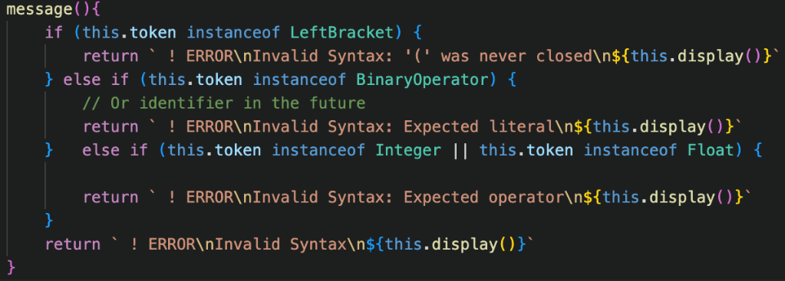This works for now, but in the future the same token may be involved in different errors, so this system will have to change.

# Design: execution

In order to get an actual value out of the calculation, we must now add the code in the Token classes.

### evaluate()

Every single token that can end up in the abstract syntax tree (so excluding the brackets) will have a method called evaluate(), that will return its value.

For example, for Integers and Floats, it will return their value property. Likewise, for any other data types that get added in the future, they will also return their own value.

However, for operators, their “value” is based off of the values of their two children. Therefore, all the operators will call evaluate() on both of their children and will use those two values and return the according value. For example, Plus will add together these two values, and return that.

This is use of abstraction allows the whole expression to be calculated. Each token just knows that its child value will return a number. Therefore, it could just be an Integer, or it could be another BinaryOperator or even a huge tree as one of its children, but it doesn’t matter. It will form a huge chain of calling evaluate() on all the BinaryOperator nodes, and because all the leaves of the tree will be Integers or Floats, this means that a value will be returned to the root of the tree.

So, after the Parser has finished, evaluate() just needs to be called on the result, as this will be the root node of the tree, and therefore the corresponding value will be returned.

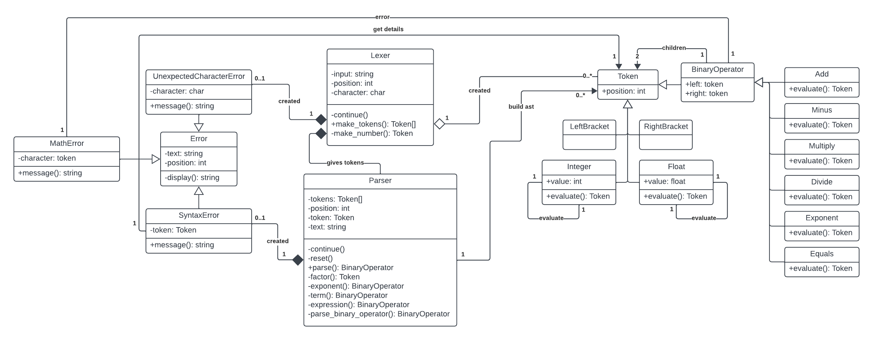The UML diagram does not massively change for this, as it is mainly just adding evaluate() calls to all of the tokens, however the updates version is as shown:

### math errors

Some arithmetic operations are illegal. The two cases of this are attempting to divide by 0, as well as raising certain negative numbers to certain powers which create imaginary numbers.

Therefore, in the evaluate() method of Divide and Exponent, we will need check if this occurs, and if it does, we return the new Math Error. For Divide, if the result of evaluating the right child is zero, then it will be returned, and Exponent will just check if the combination of the two values will create a Number.

Now, because an Error can be returned from an evaluate() method, all the Binary Operators will have to check that the results of the two evaluate() methods it calls are not errors. If they are, it will have to return it too, much like how the Parser will return an error instead of building it into the AST.

This means that calling evaluate() on the root node will either return a value or an Error, so an additional check in the Shell class must be added so this error can be displayed if needed.

Finally, this new MathError class will essentially be the same as SyntaxError but with a different name, also accepting a token as a parameter, and with different error messages based on the token passed.

## unary operators

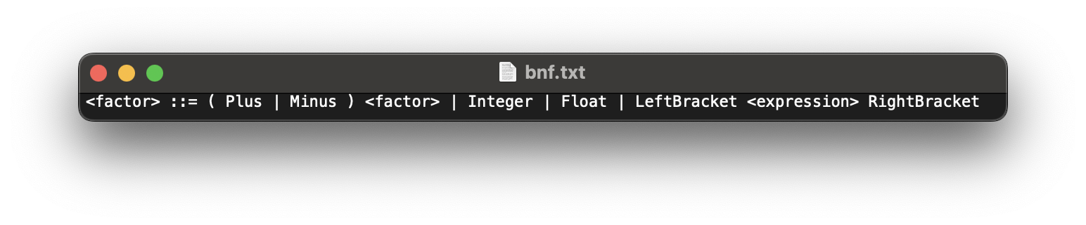Because I did not add them in the last section, I need to add unary operators to the factor() method, with the new BNF being as shown:

The changes here are that a <factor> can now be defined as a Plus or Minus followed by a <factor>, so these additional cases must be added.

🡺 Plus <factor>

Because a plus in front of a number does not change the value, then whenever a Plus token is detected in factor(), it will continue() past it, and then call factor() again, and return that result.

🡺 Minus <factor>

However, a Minus does change the value of the thing after it. So, when a Minus token is detected in factor(), it will continue() past it and call factor(), like for the Plus. However, instead of directly returning the result, it will create a new Minus operator, setting the left child to an Integer with value 0, and setting the right child to the result of calling factor(), and will return the Minus.

Therefore, in the AST, this will return the negative value of the number, so the unary operator will produce the correct value, even if it is using multiple tokens to do so.

I will also need to implement full error handling for both of these tests, but I will do that when developing, trying out different cases and adding fixes for them all.

# development: execution

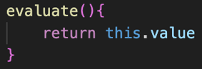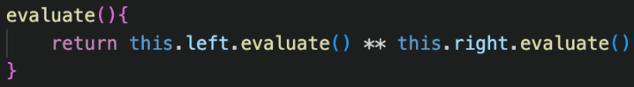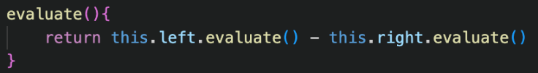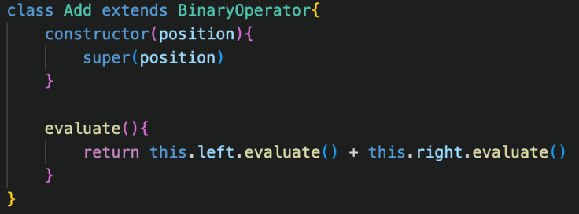Adding the execution itself is extremely simple, just adding each of the evaluate() methods, and you can see a few cases here.

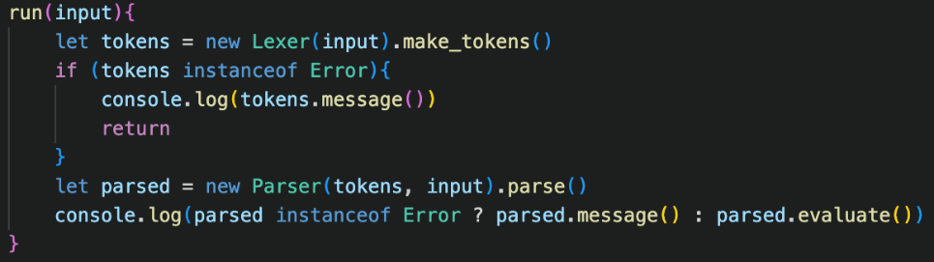The case just returning the value is for Integers and Floats, as per the Design,

Now, the run() method in Shell just has to be slightly changed to call evaluate() on the result of the Parser (the rood node of the syntax tree), and then to output the result of this for testing purposes.

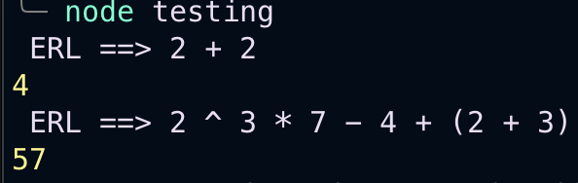This immediately works, and as you can see it shows that the way the parser arranged the AST is correct, because the precedence and associativity of BODMAS is properly followed.

This is great in showing that the valid cases are now complete!

## ERROR HANDLING

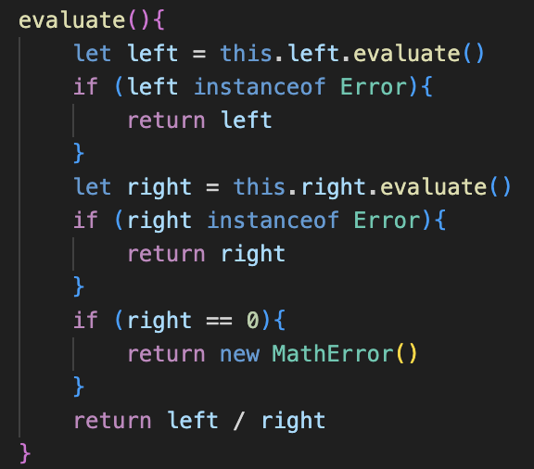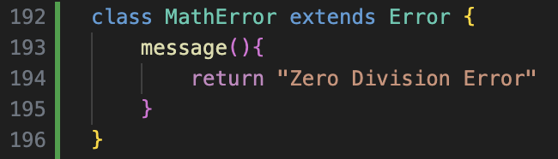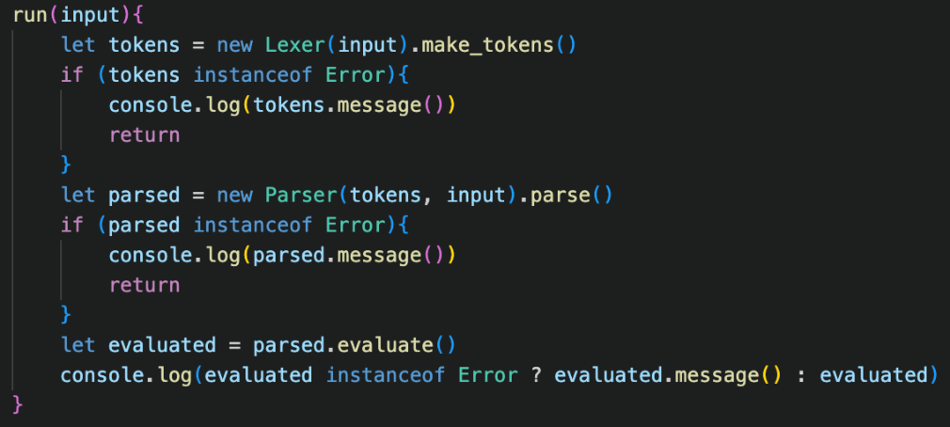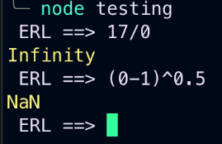Currently, when we try to perform our illegal operations, we just get returned with the default JavaScript values, which is not what I want for this project, as if a student sees Infinity or “NaN” (the Not a Number data type) it would be very confusing. Instead, I need to make these calculations return errors.

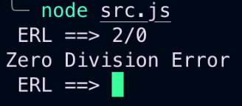For now, I added a basic version of the MathError, without accepting a token or plaintext, because I have realised a major issue with how errors work.

However, the check in Division’s evaluate() method correctly detects when the program attempts to divide by 0.

### issues with errors

Currently, the errors have no way of being able to receive the text that they need to use for the display() method. Previously, it was stored in both the lexer and the parser, but for errors in evaluation a different system is needed to have a global place to store the plaintext.

Otherwise, we would have to give every single instance of Token a copy of the plaintext, which would be very inefficient for the memory, so this global place to access the plaintext is needed.

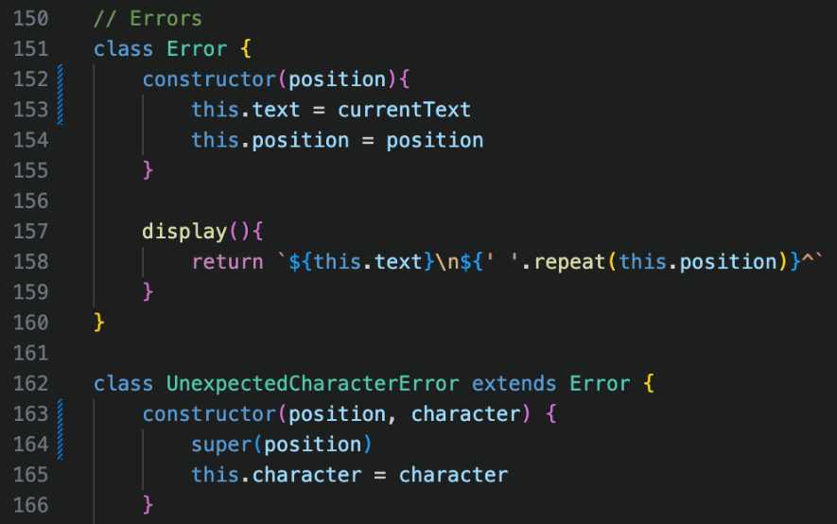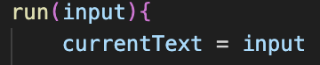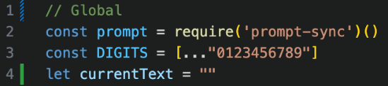My solution is to create a global variable called currentText, which will reflect the plaintext of the line that is currently being run.

Now, for all Error classes, rather than having the text passed as a parameter, the Error class sets the text property to the current value of currentText.

We therefore also update all subclasses of Error to no longer take in the plaintext and to only pass position to the super() call.

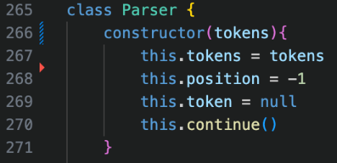Additionally, I no longer need the Parser class to store a copy of the plaintext as it no longer needs to pass it for errors.

This seems like a much more logical approach in general.

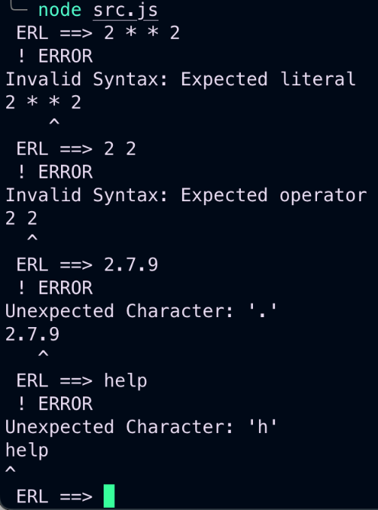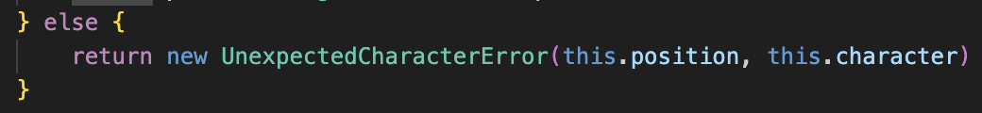Finally, all the old error messages must be updated to no longer pass in the text.

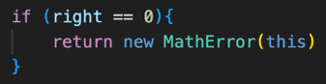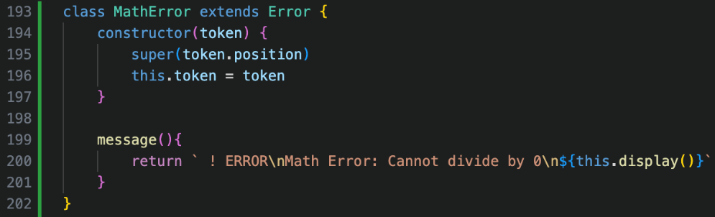As shown on the left, all of the different errors still work properly, with their display() methods still displaying the text.

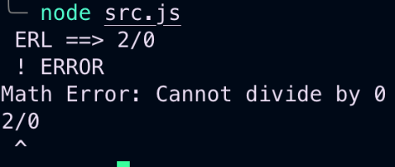Now the Math Error class can be properly implemented as shown, with the error token being the Division rather than the number, as I feel it is more logical than pointing to the number.

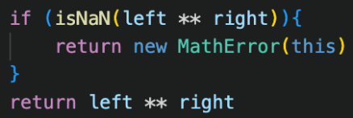As shown on the right, this error handling now correctly functions.

The implementation for preventing imaginary numbers is very similar, adding an case into Exponent’s evaluate() method to check if the result of the power would be NaN.

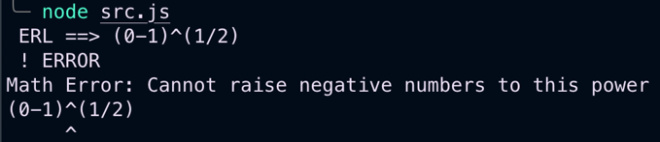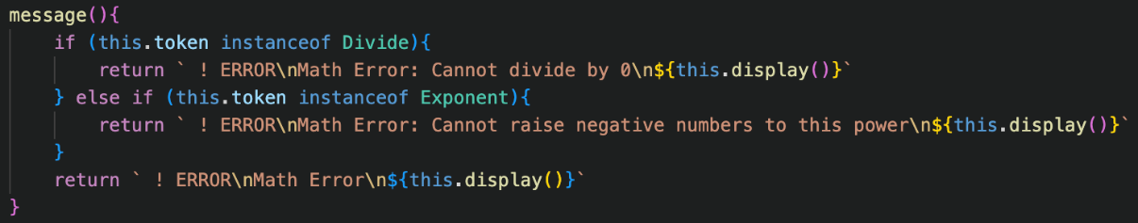I also added a new error message if the token which raised the Math Error was an Exponent for clarity.  
Now the Math Errors are fully implemented.

### Error issues

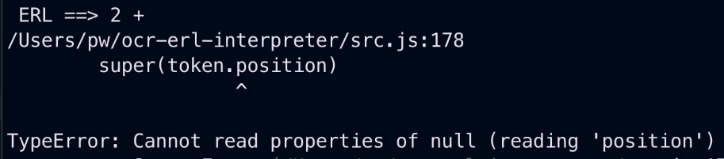When running some tests, I realised that trying to write an incomplete expression caused the program to completely break, which therefore needed addressing.

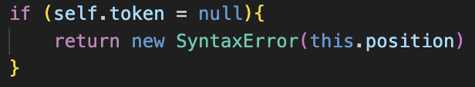The fix was simple enough: in parse_binary_operator(), after continuing past the operator, the current token must be checked if it is null, as otherwise it attempts to parse a non-existent token which causes lots of errors.

This addition is simple; however, it revealed a huge flaw with how the error handling in the program was implemented and led to me writing some very messy and very poor code.

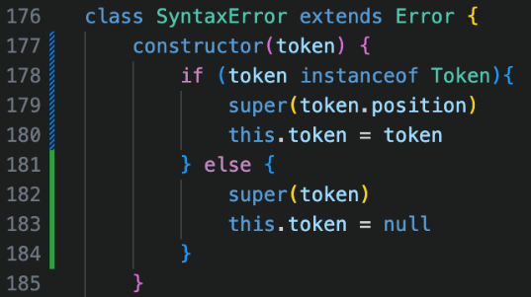This is because if I were to just pass the operator Token into the Syntax Error call, it would see that it was an operator and therefore would output that it expected a literal when this type of error is a different kind to having two operators in a row in the input. My message() presumed that there could only be one type of error per type of token, which is a huge flaw.

Instead of deciding to fix this, I instead decided that I would not pass a token but pass an integer if there was an incomplete input error, and this integer would correspond to the position of the operator token which was incomplete.

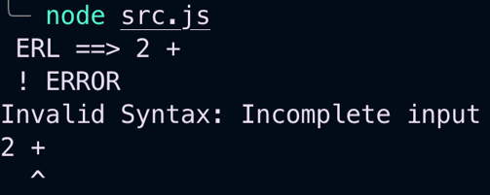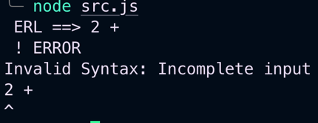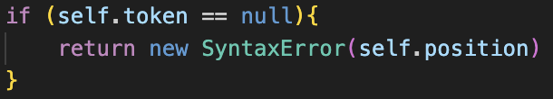At first this bad implementation didn’t even work, but after realising that I’d used both a single = and this instead of self after a lot of debugging output statements, it then worked.

Regardless, this solution was a bad idea – and just led to me being forced to redesign error handling later anyway. This to me felt extremely messy in the moment of writing it, but I procrastinated cleaning it up, which – with hindsight – is really poor development and something that I avoided doing moving forward.

## Unary operators

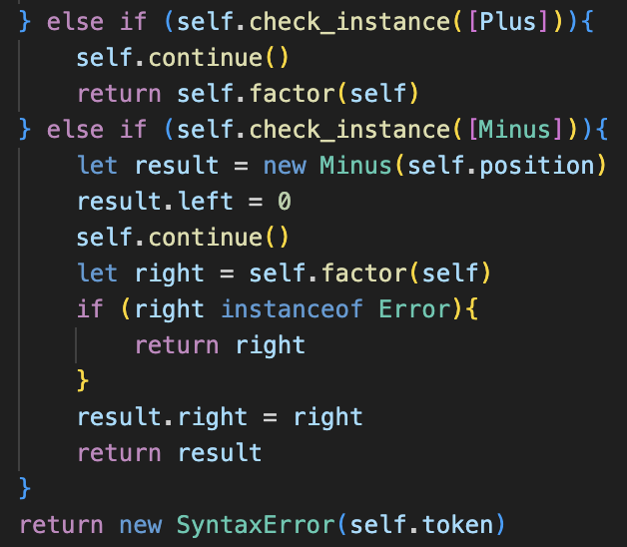Deciding to ignore the state of errors for now, I moved on to implementing Unary operators. My first attempt and implementing this was along the right lines, but with a lot of Errors. Firstly, I had was checking for Plus when my it should have been Add.

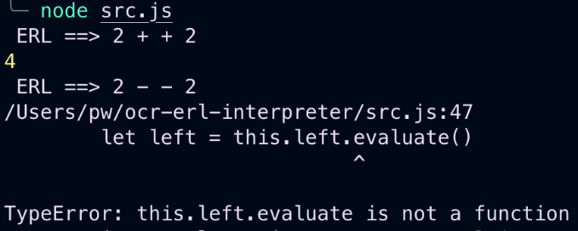After fixing this, I tried to run the code and found that addition worked, but subtraction resulted in an error.

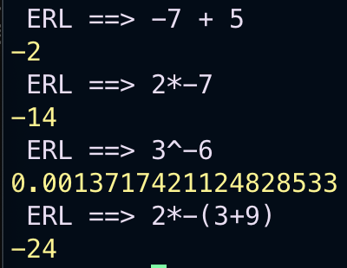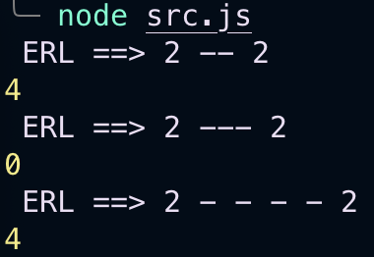This is because I was attempting to call evaluate() on just a basic JavaScript Number data type, rather than my custom Integer data type.

After changing the left child to my own custom 0 and then it worked properly.

Now I had all the arithmetic features of the BODMAS stage implemented into the program, but before finishing I must deal with the absolute mess of error handling, I had left the program with, as it is currently unsustainable.

## Fixing errors

### Unary operators

When testing the new unary operator for errors, I realised that the error message pointed to the completely wrong position for the incomplete input, as I wanted the last minus token to be the error token.

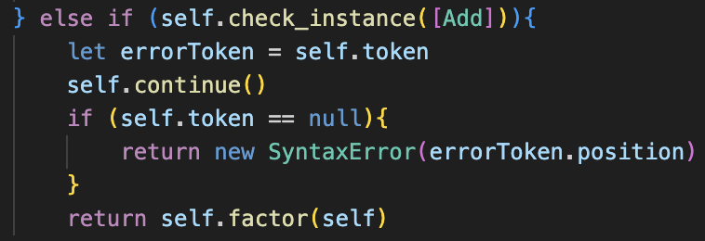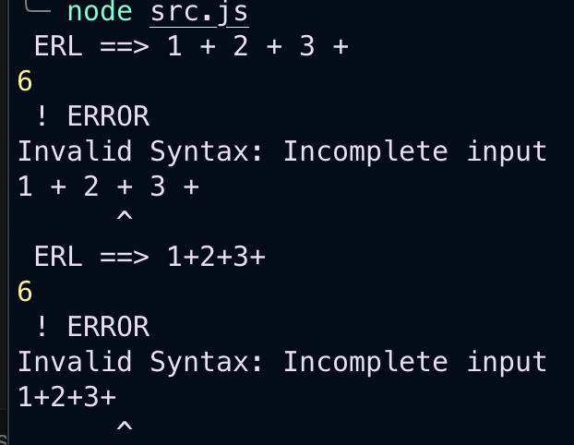When adding output messages to check this, I realised that it was not just for unary operators, but all incomplete inputs. As you can see, the pointer pointed to the same position, regardless of if there were spaces between the different tokens or not, which made me realise that the error was being passed the parser’s position, rather than the token’s position.

This was easy to fix, and adding cases for incomplete unary operators is just checking that the following token is not null.

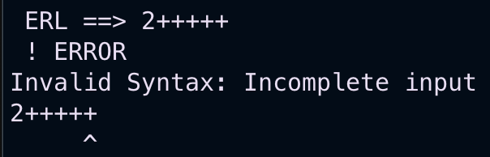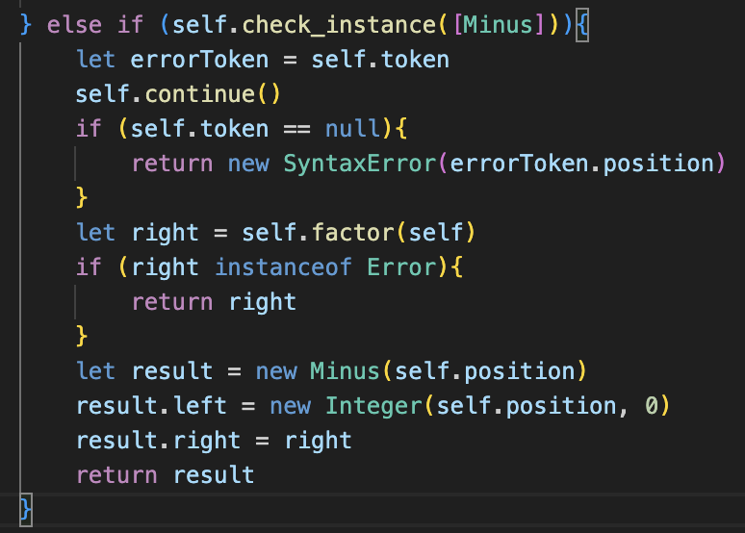This did fix the issues; however this implementation is horrible, and I need consistency with always passing a token, so I am going to redesign all of Errors.

### Redesign

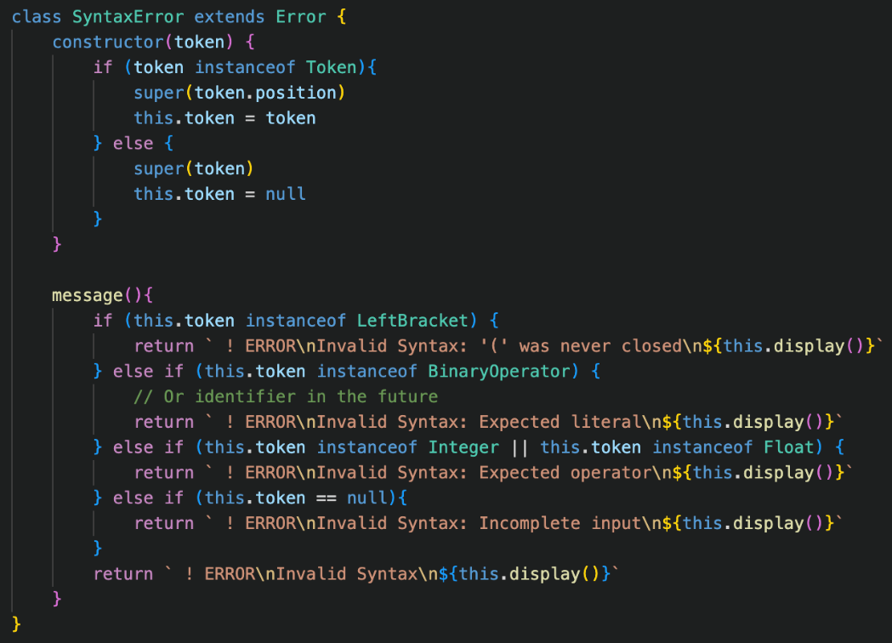The main issue is with the really badly designed code on the left.

The code will receive the error token, and then from there will guess the type of error based on this token. This worked well initially because each token could only be involved in one type of error.

But now that the same kind of token can be involved in multiple different errors, this is not suitable at all, and I have had to use some weird workaround to pass an Integer instead of a Token if I want a specific kind of error, which is horrible implementation and will not be possible to reuse further into the project.

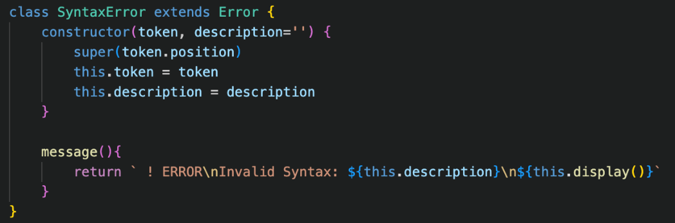The solution to this is giving the SyntaxError an additional parameter in its constructor, called description, which will take in a string to describe the error alongside the token, so no more guessing needs to take place.

This solution is a lot more expandable, as now the same token type can be in numerous errors.

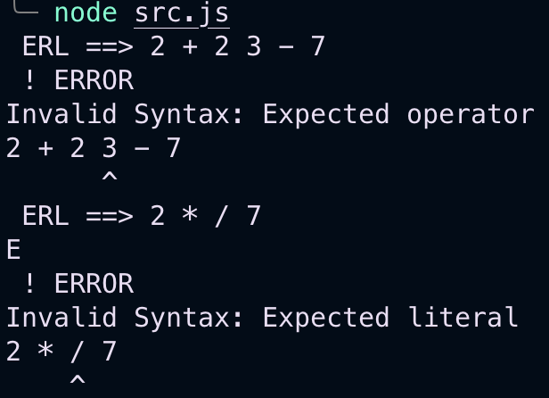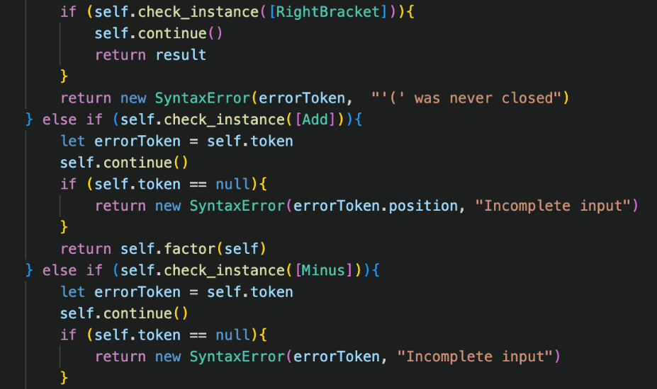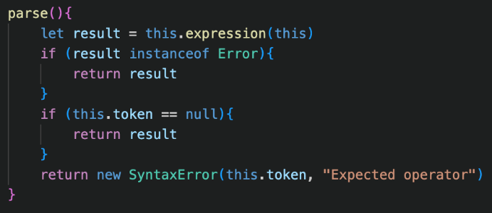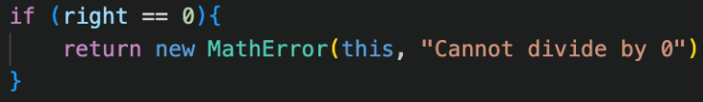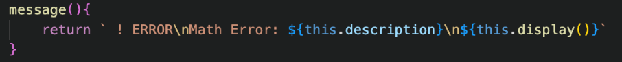This also significantly improves the readability of the program, as now there will be lots of string descriptions throughout the project, explaining why an error case could occur, rather than just a random Error being produced with no detail as to why it was an issue.  
  
There are a few examples above of these changes, as it had to be done to the entire program in every single place that an error occurred.

I also updated the other error types to also use this system, such as MathError, so that it no longer has to base its message off of the token.

There were quite a lot of errors when initially testing the system, due to some forgotten updates, however I eventually got them all working.

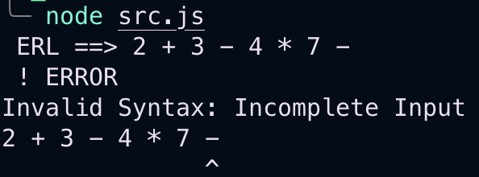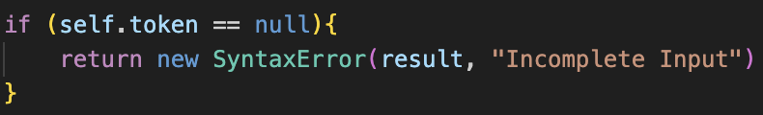Now the incomplete input could just be given the token directly, rather than messy solution of the integer position being passed.

This just made the code so much more consistent and logical, and I was finally happy with the way that the errors were being managed, as it made a lot more sense.

This is also positive for the rest of development, as if these changes were not implemented, there would be major issues later on.

## Less repeated code

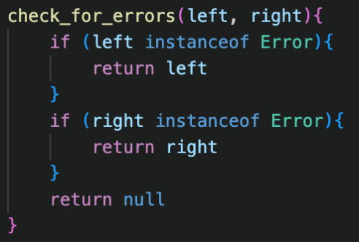My last issue is that there is a lot of repeated code in the error checking for the Binary Operator’s evaluate() methods, because every single method includes evaluating the left and right children and checking them both for errors which adds the same set of repeated code in every single class.

My solution for this is creating a new method in the Binary Operator class called check_for_errors(), which takes in two inputs: the result of the left evaluated() method and the result of the right, and will return an error if there is one, and null otherwise.

This will allow every class to easily check for errors with less repeated lines: returning the operation if the result is null, and the result if it isn’t.

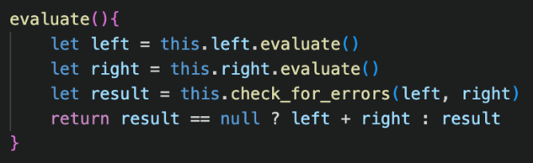An example for Plus’s evaluate() method is shown on the left, and it is clear how much this reduces the number of lines used.

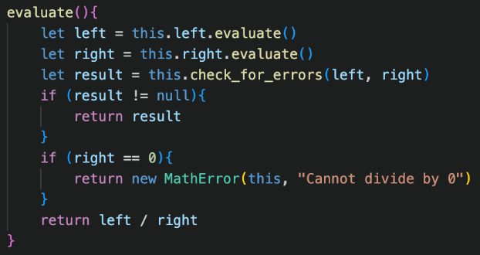Now, this just must be replicated for every single binary operator so they all use this system.

For operators that require additional checks, they just perform this check after the full error checking has been completed, as shown for Division on the left.

When testing this, it still worked perfectly as expected: this was just a small addition to reduce repeated code and didn’t impact the result at all which is perfect. I still feel this could be improved, as there are still a lot of repeated lines, but it is a lot better than before.

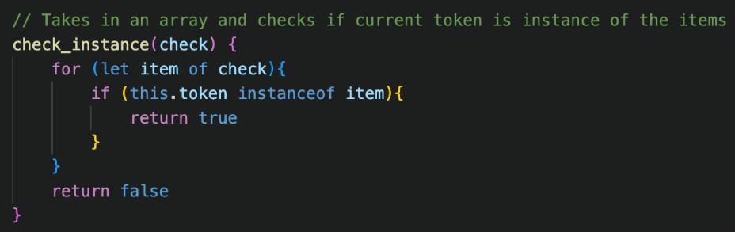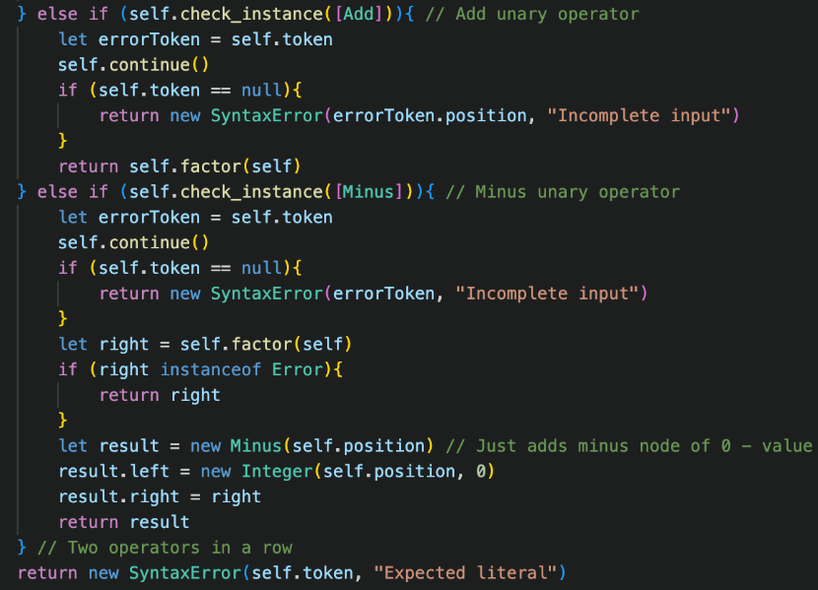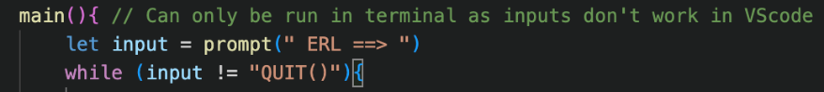Finally, before concluding this stage of development, I just added some comment to some of the less self-explanatory methods I implemented to make it easier for myself in the future to re-read bits of code. My aim with writing code is to make it obvious based on just the code itself, but this extra level of detail is useful

This concludes this stage of development, and I am relatively happy with the system after this phase.

# evaluation

After each phase of development, I just want to briefly go over the success criteria of that phase, to ensure that I am not ignoring any features, and know what I must come back to afterwards.

|  |  |  |
| --- | --- | --- |
| No. | Criteria | Implemented? |
| 1.1 | Allow for Addition, Subtraction, Multiplication, Division, Exponentiation, Modulus and Quotient division to be taken of two Integers | **No** |
| 1.2 | Allow multiple operations to be chained together, following the BODMAS order of operations. | **Yes** |
| 1.3 | Allow for Floats to be used and created, and for any calculation involving Floats to return another Float | **Yes** |
| 1.4 | Allow brackets and infix operators + and – to be used in expressions | **Yes** |
| 1.5 | Proper error handling is implemented, ensuring division by zero, unexpected characters and invalid syntax errors are managed | **Yes** |

The issue with 1.1 is with Modulus and Quotient. These operations, instead of using symbols, use the keywords MOD and DIV to function. Therefore, I have decided to implement them later, after I have implemented keywords into the Lexer, as I feel like a temporary solution, I implement now would not be great.

However, because of the way I have built the project in this phase, I am not at all worried about their implementation, and it should be very straightforward to add them based on the current system: adding them to the array of valid tokens in the corresponding method that calls parse_binary_operator(), and adding their tokens to the Lexer and having the calculation code.

### code quality

At the end of this module, I am happy with how well the code has been written. Throughout, I had lots of periods of writing poor fixes to code rather than just redesigning the system, which I think is important to take forwards throughout the project: it is better to just do the hard work of re-doing a system than just implementing some poor system. In this section, this was my terrible error handling, however by fix at the end seems very good, and should be usable for the remainder of the project.

### stakeholders

At the end of some modules, I will show my stakeholder, Tanish Arjaria, my progress to ask for feedback. At this point of the program, although I have done a lot of work, there is not much to show for it.

I did still show him my progress, however because it is just a calculator, there was not really any useful feedback to report on his end because it is currently just the foundation of the project. In the future modules, I will try and report better on what he thinks as it may be useful, however in the nature of the strictly defined ERL code, there will probably not be much feedback.